<https://www.youtube.com/watch?v=efR1C6CvhmE&list=PLblh5JKOoLUICTaGLRoHQDuF_7q2GfuJF&index=55>

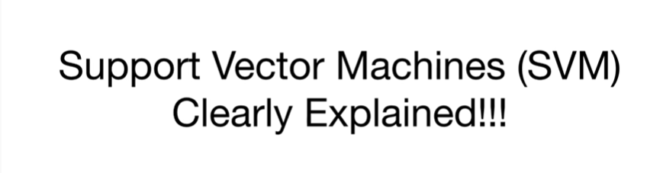

Today we're going to talk about support vector machines and they're gonna be clearly explained.

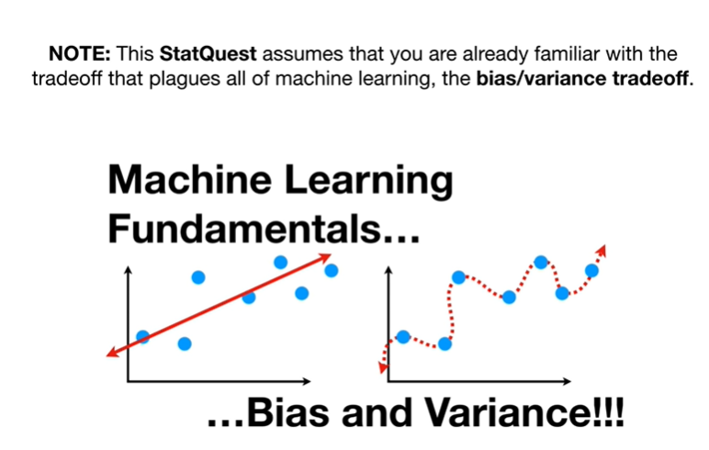

Note this stack quest assumes that you are already familiar with the trade-off that plagues all of machine learning, the bias-variance tradeoff.

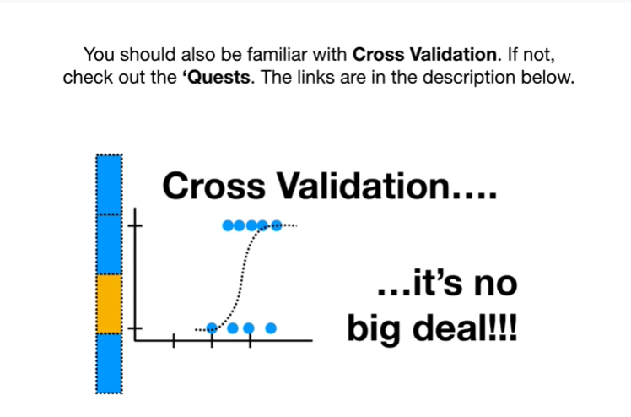

You should also be familiar with cross-validation, if not check out the quests.

The links are in the description below.

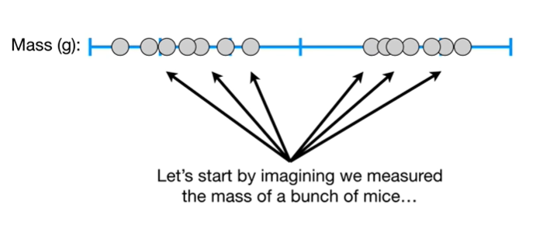

Let's start by imagining we measured the mass of a bunch of mice.

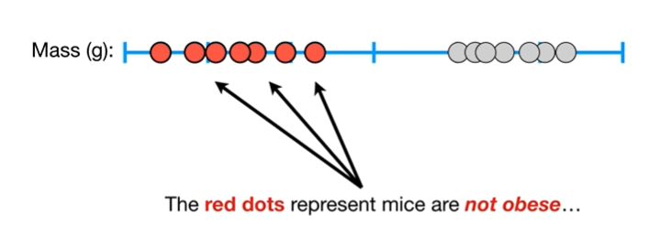

The red dots represent mice that are not obese.

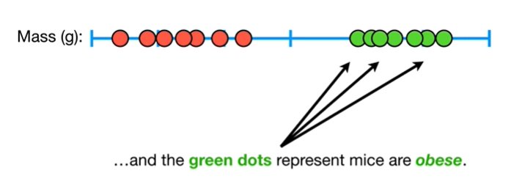

And the green dots represent mice that are obese.

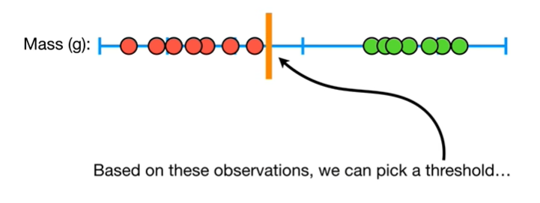

Based on these observations, we can pick a threshold

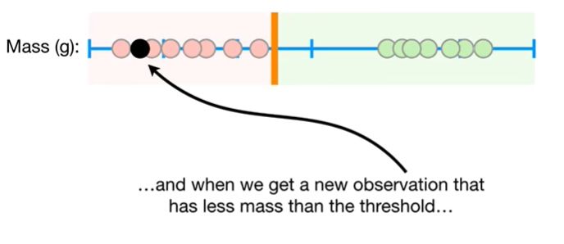

and when we get a new observation that has less mass than the threshold

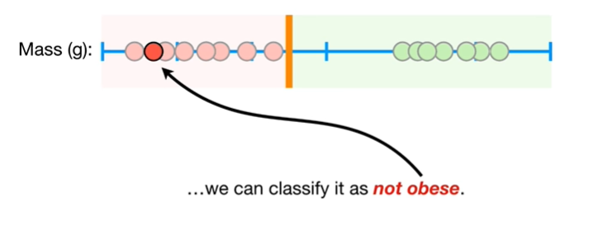

we can classify it as not obese.

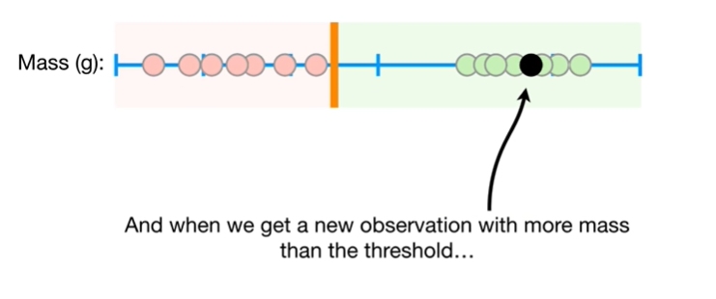

And when we get a new observation with more mass than the threshold

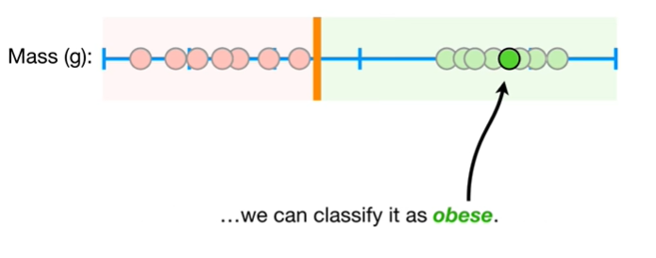

we can classify it as obese.

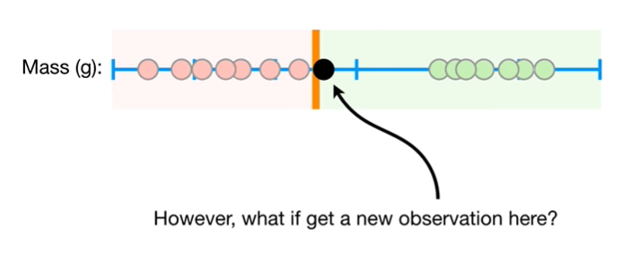

However what if we get a new observation here ?

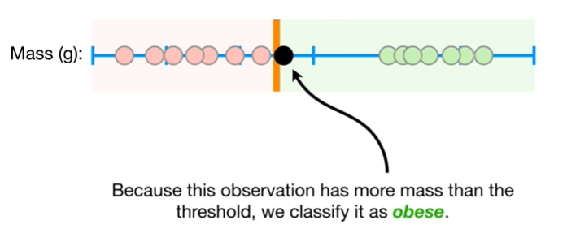

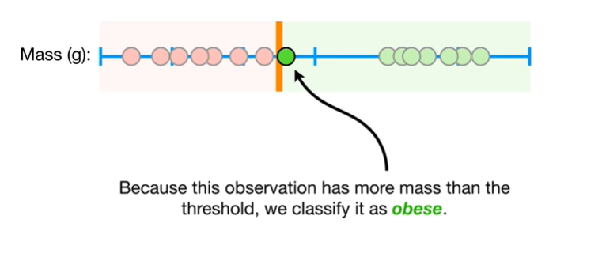

Because this observation has more mass than the threshold, we classify it as obese.

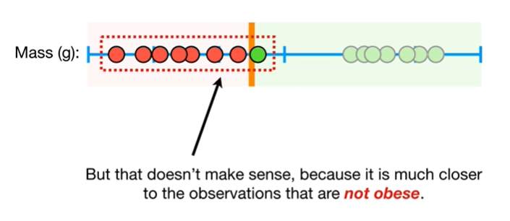

But that doesn't make sense, because it is much closer to the observations that are not obese.

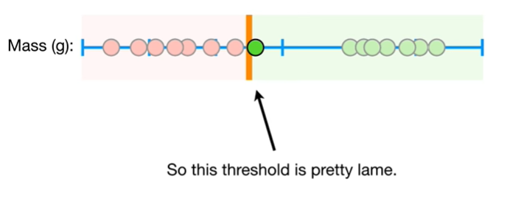

So this threshold is pretty lame.

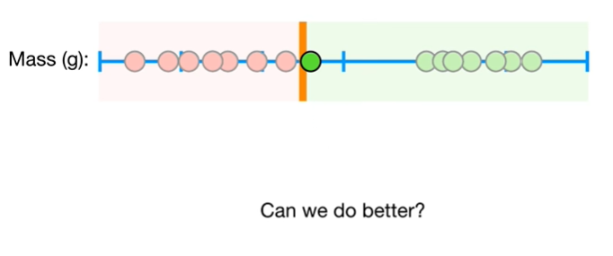

Can we do better ?

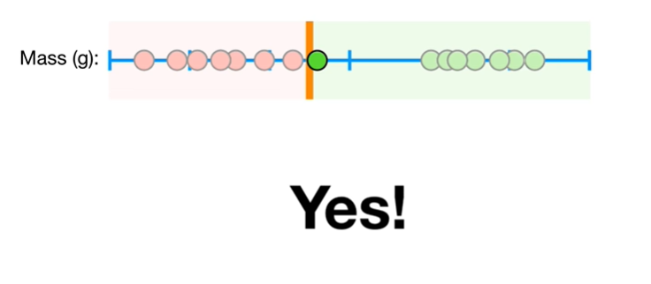

Yes !

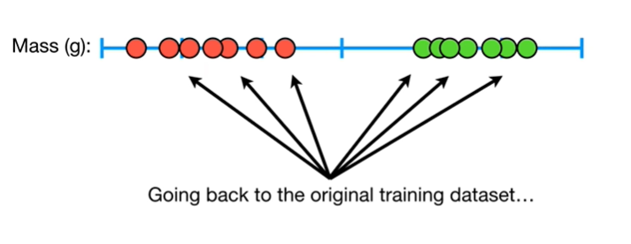

Going back to the original training data set

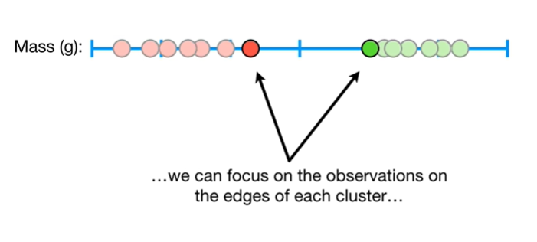

we can focus on the observations on the edges of each cluster

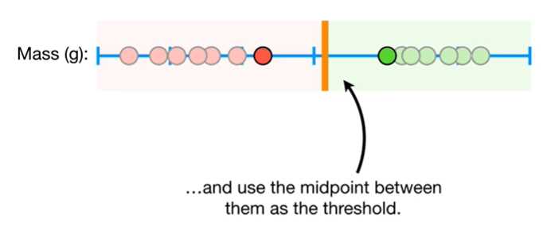

and use the midpoint between them as the threshold.

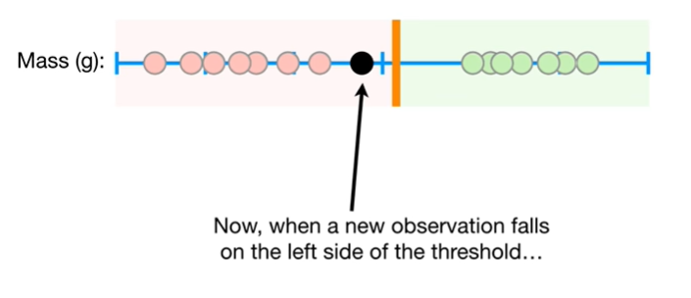

Now when a new observation falls on the left side of the threshold

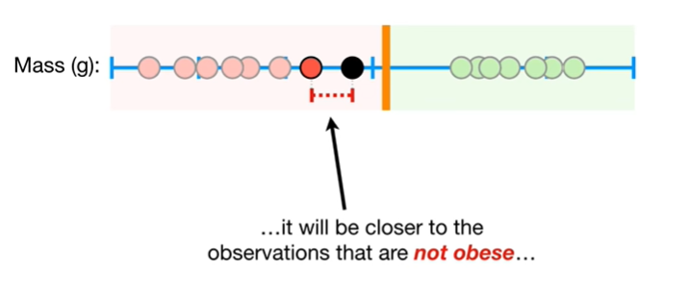

it will be closer to the observations that are not obese

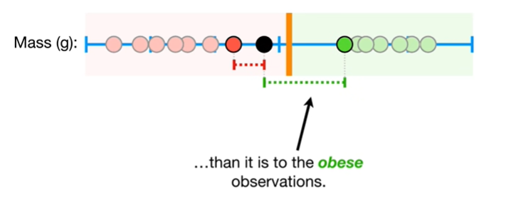

than it is to the obese observations.

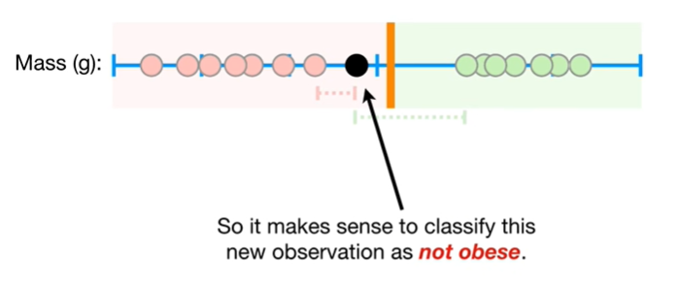

So it makes sense to classify this new observation as not obese.

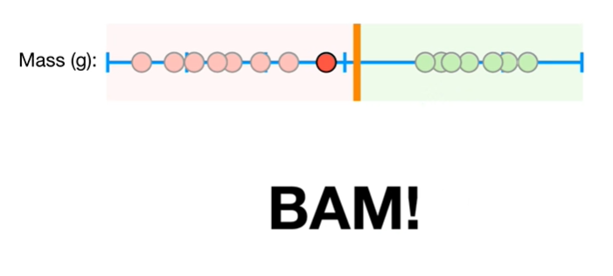

BAM !!!

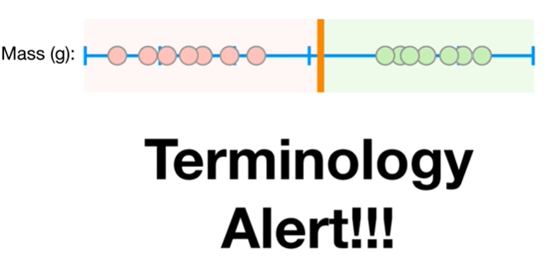

Oh no it's a terminology alert !!!

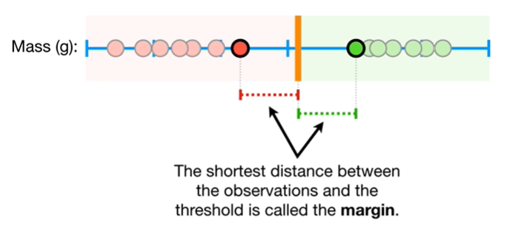

The shortest distance between the observations and the threshold is called the margin.

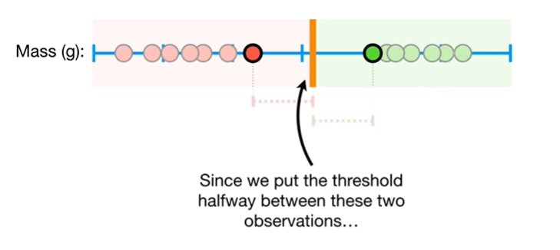

Since we put the threshold halfway between these two observations

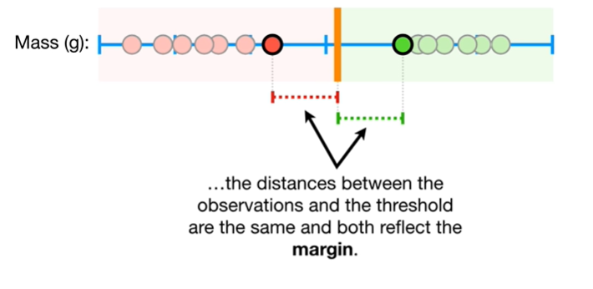

the distances between the observations, and the threshold are the same and both reflect the margin.

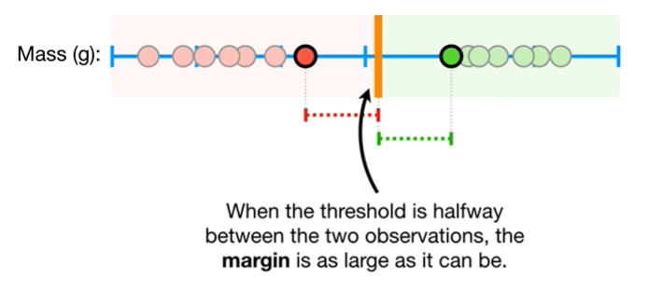

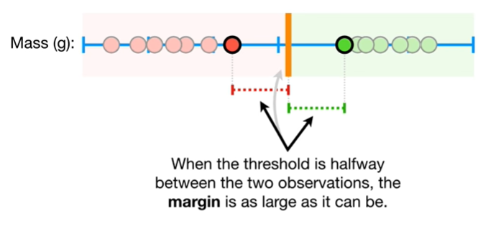

When the threshold is halfway between the two observations, the margin is as large as it can be.

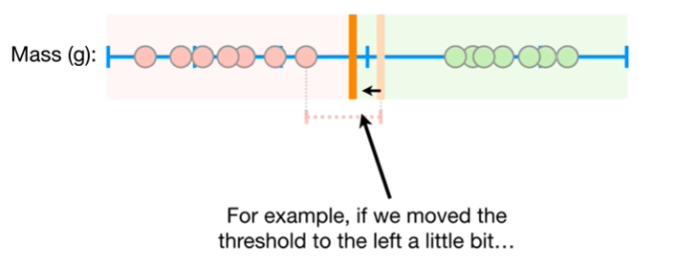

For example if we move the threshold to the left a little bit

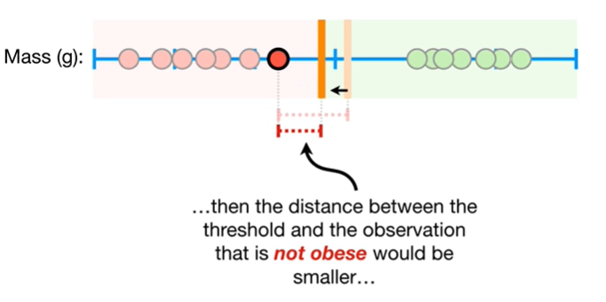

then the distance between the threshold and the observation that is not obese would be smaller

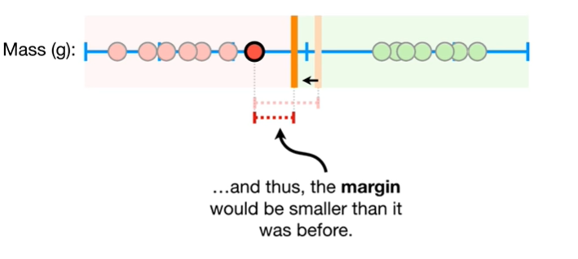

and thus the margin would be smaller than it was before.

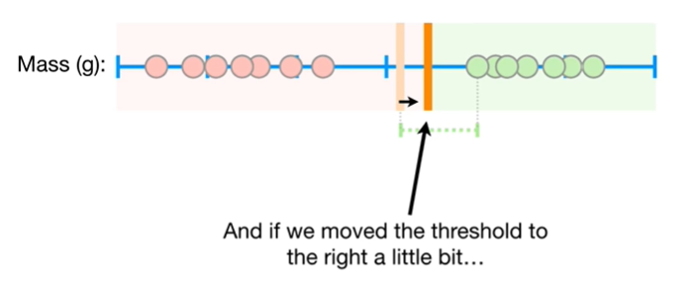

And if we move the threshold to the right a little bit

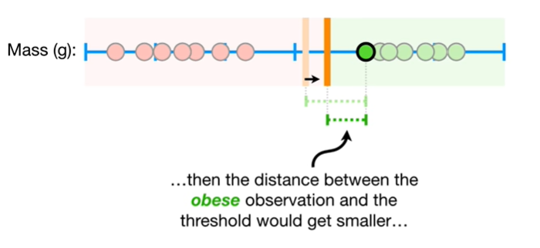

then the distance between the obese observation and the threshold would get smaller

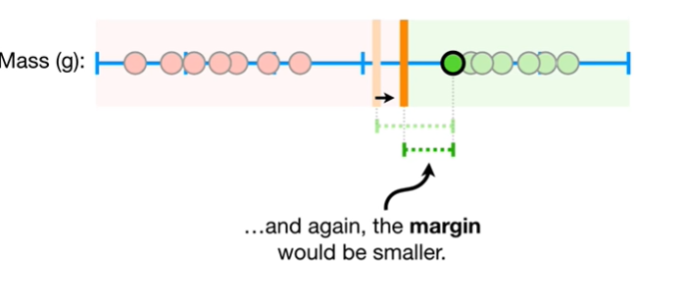

and again the margin would be smaller.

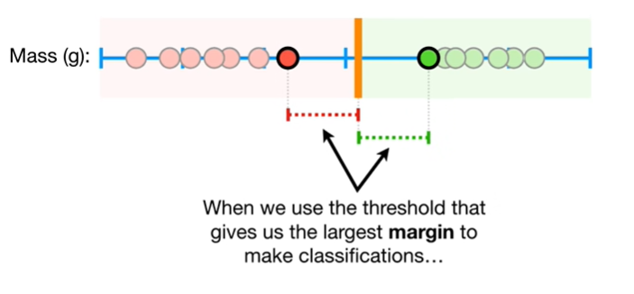

When we use the threshold that gives us the largest margin to make classifications

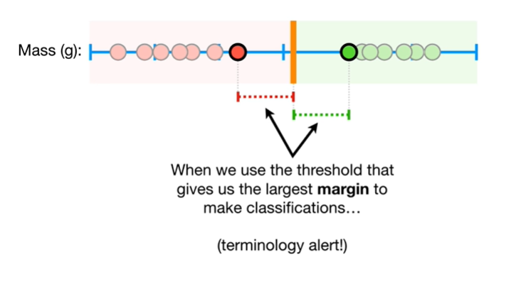

heads up terminology alert !

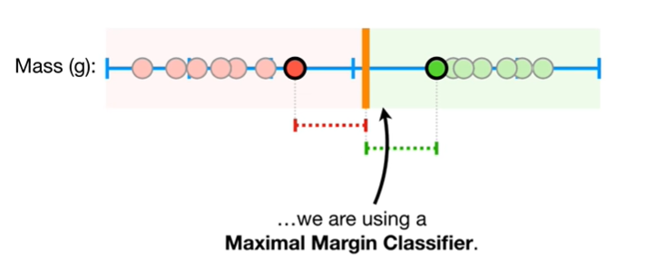

We are using a maximal margin classifier.

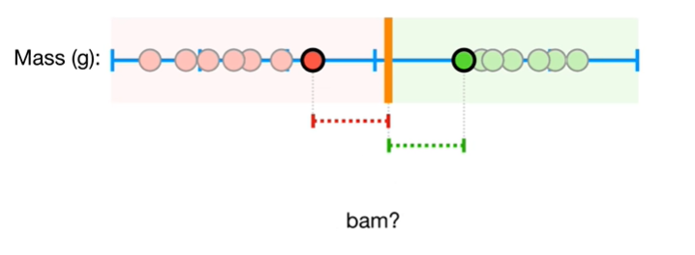

BAM ?

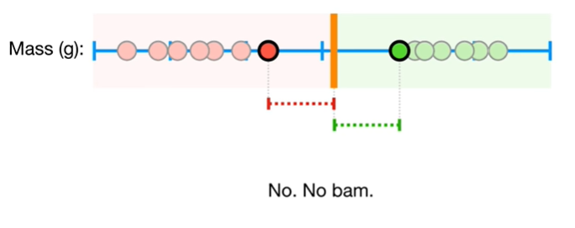

No, no BAM.

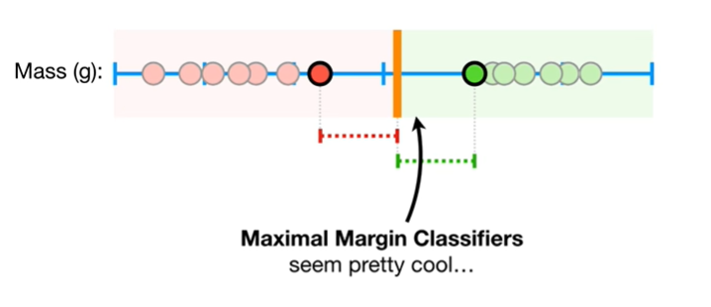

Maximal margin classifiers seem pretty cool

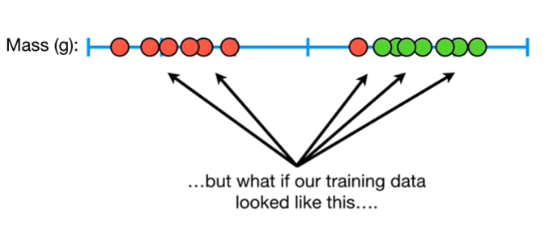

but what if our training data looked like this

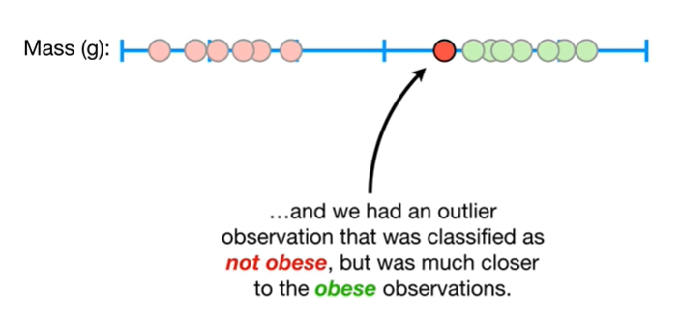

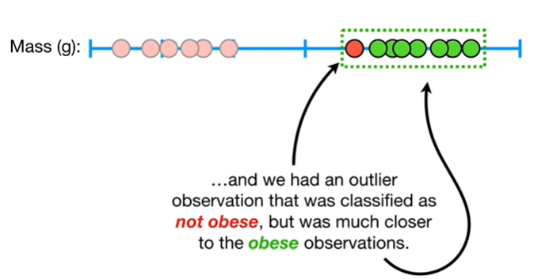

and we had an outlier observation that was classified as not obese but was much closer to the obese observations.

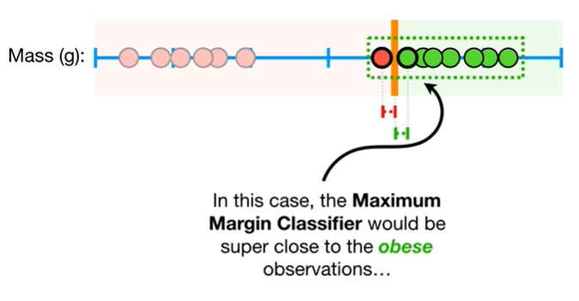

In this case the maximum margin classifier would be super close to the obese observations

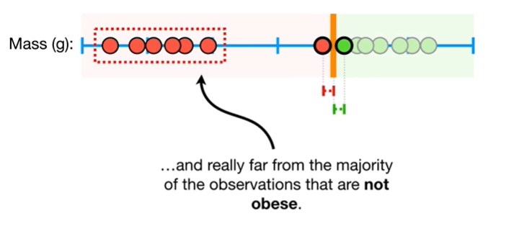

and really far from the majority of the observations that are not obese.

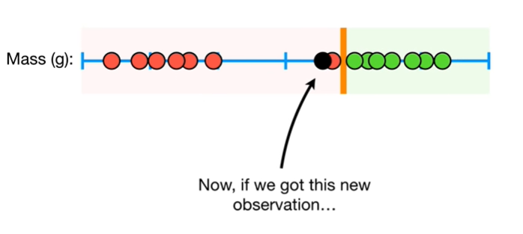

Now if we got this new observation

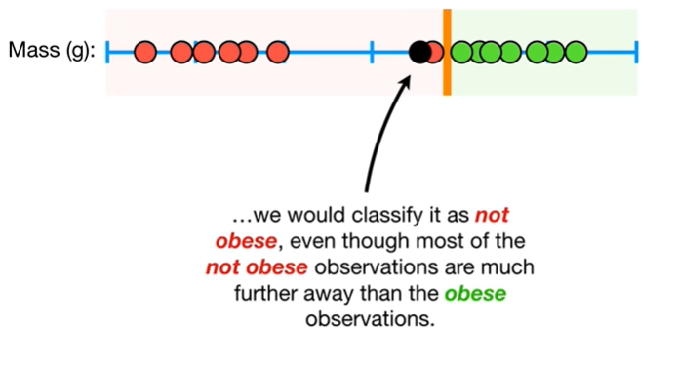

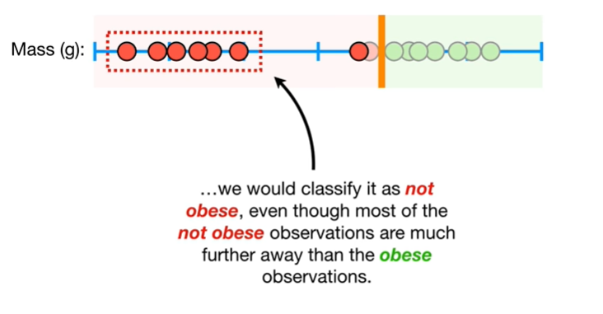

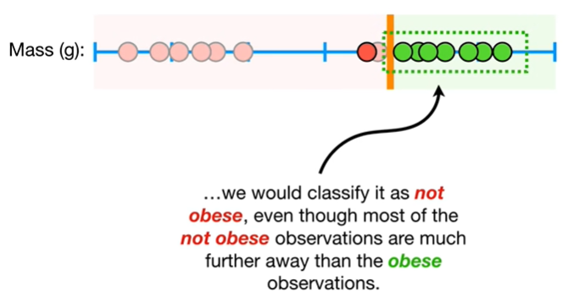

we would classify it as not obese even though most of the not obese observations are much further away than the obese observations.

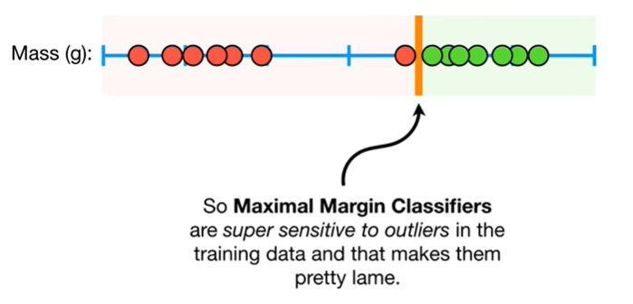

So maximum margin classifiers are super sensitive to outliers in the training data and that makes them pretty lame.

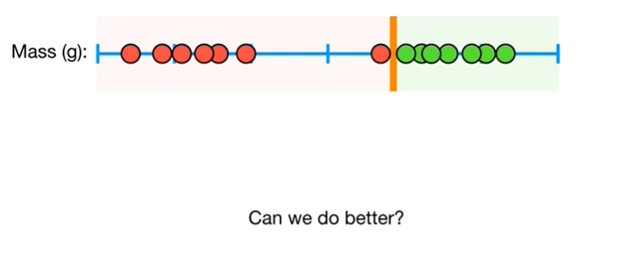

Can we do better ?

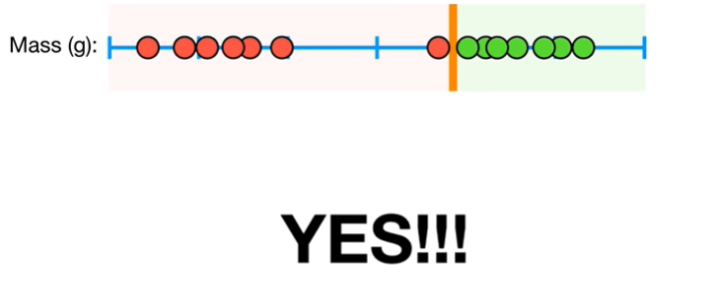

Yes !!!

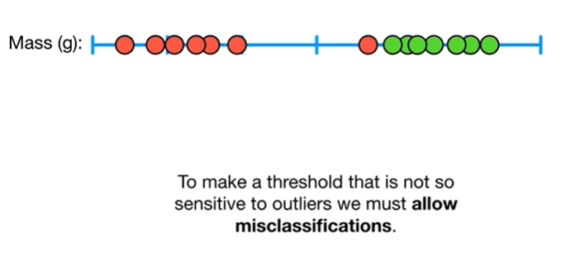

To make a threshold that is not so sensitive to outliers we must allow misclassifications.

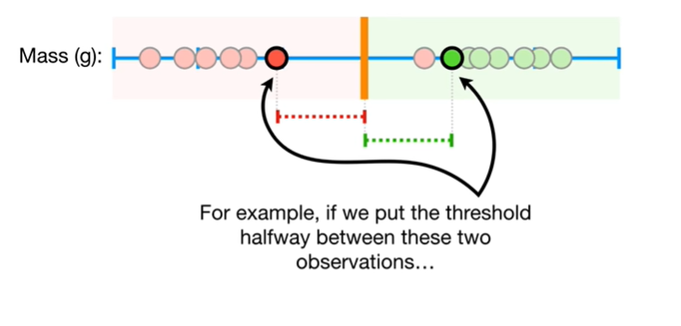

For example if we put the threshold halfway between these two observations

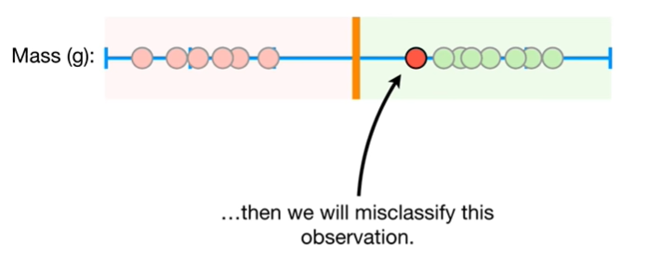

then we will miss classify this observation.

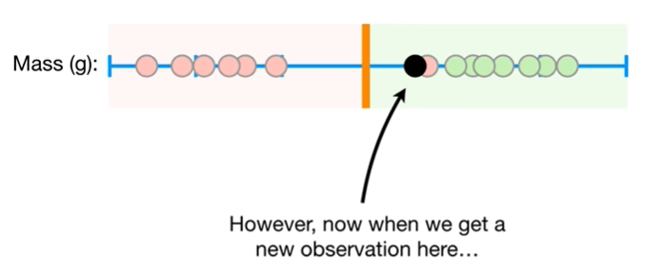

However now when we get a new observation here

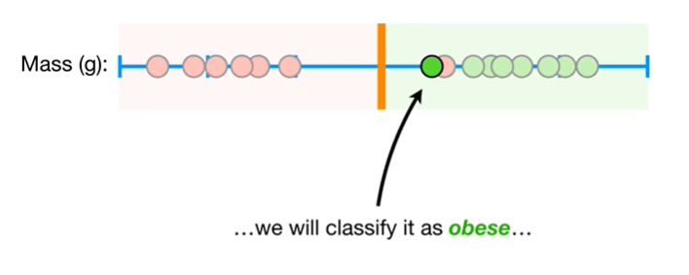

we will classify it as obese

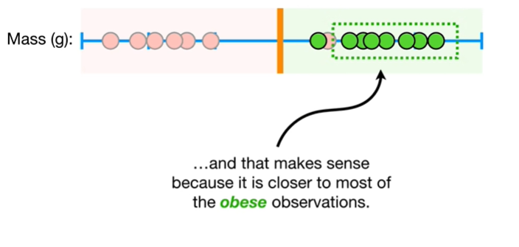

and that make sense because it is closer to most of the obese observations.

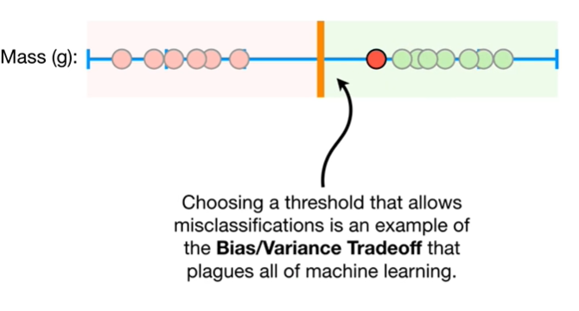

Choosing a threshold that allows misclassifications is an example of the bias-variance tradeoff that plagues all of machine learning.

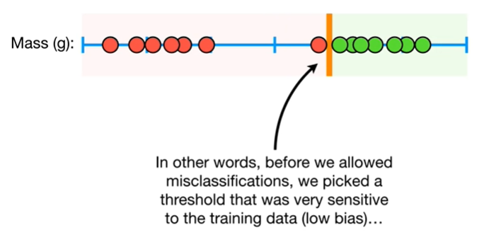

In other words, before we allowed misclassifications we picked a threshold that was very sensitive to the training data it had low bias

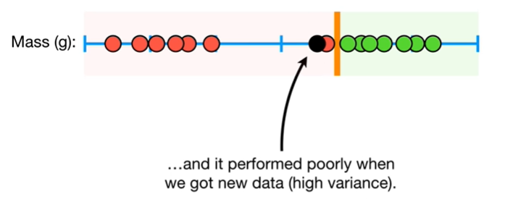

and it performed poorly when we got new data, it had high variance.

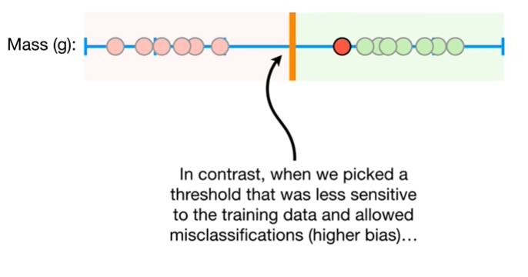

In contrast, when we picked a threshold that was less sensitive to the training data and allowed misclassifications so it had higher bias

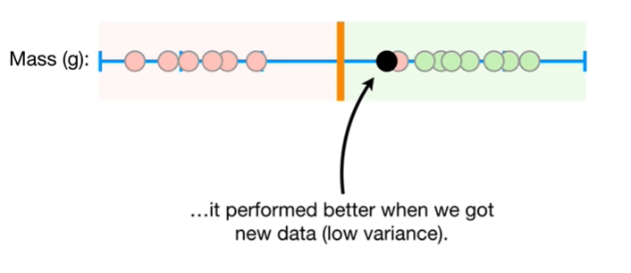

it performed better when we got new data,so it had low variance.

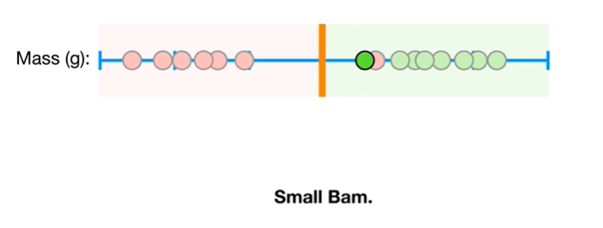

Small BAM !

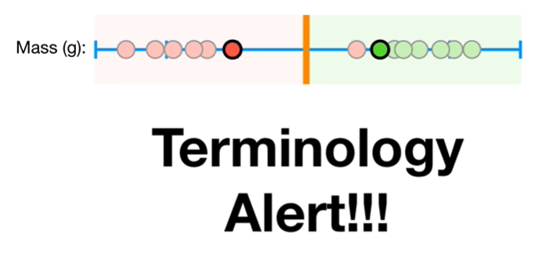

Oh no it's another terminology alert !!!

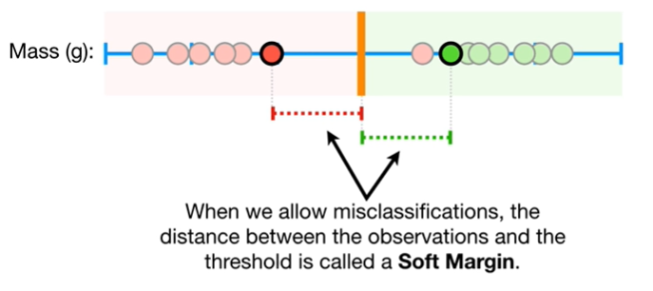

When we allow misclassifications the distance between the observations and the threshold is called a soft margin.

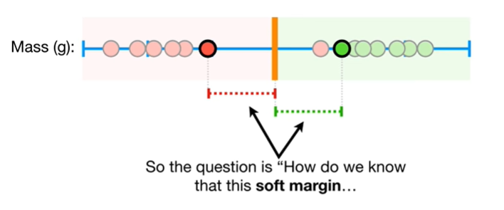

So the question is how do we know that this soft margin

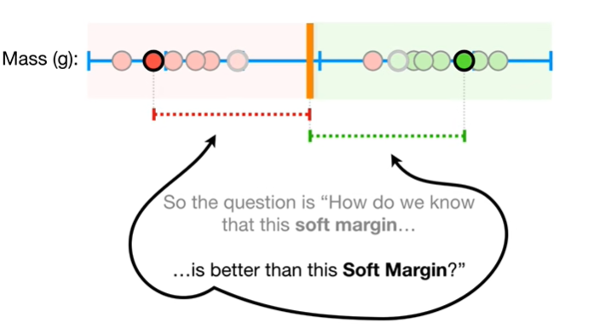

is better than this soft margin ?

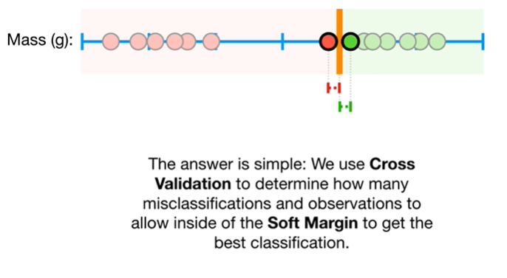

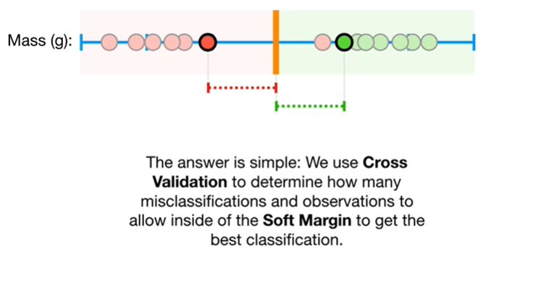

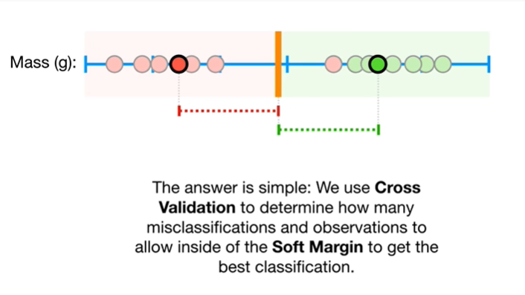

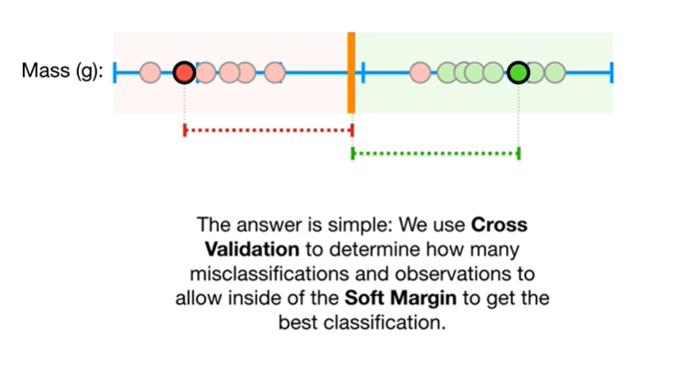

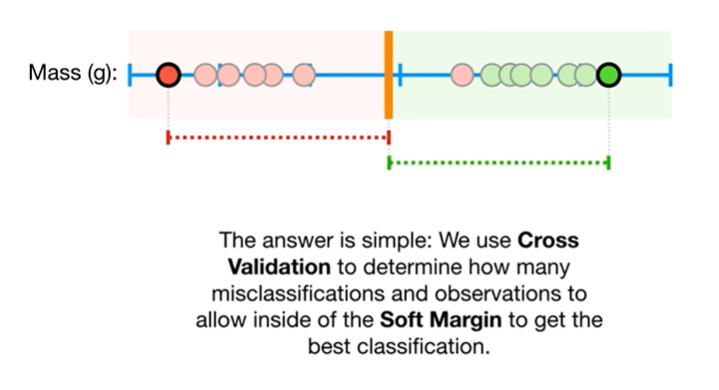

The answer is simple we use cross-validation to determine how many misclassifications and observations to allow inside of the soft margin to get the best classification.

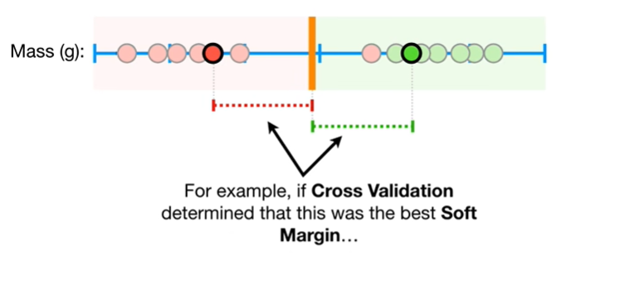

For example, if cross-validation determined that this was the best soft margin

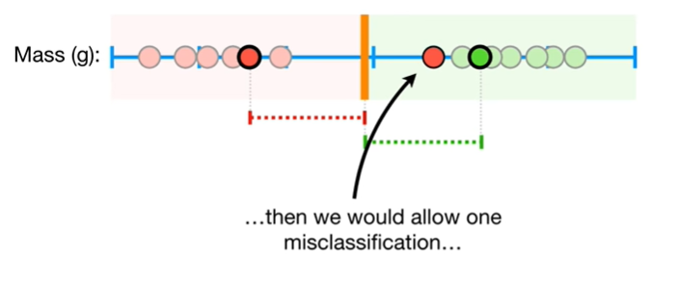

then we would allow one miss classification

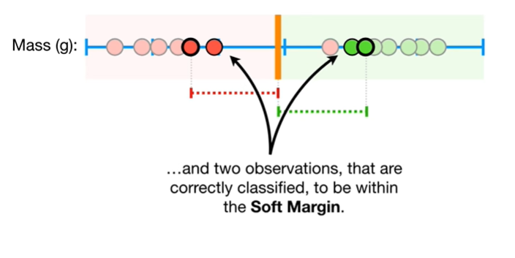

and two observations that are correctly classified to be within the soft margin.

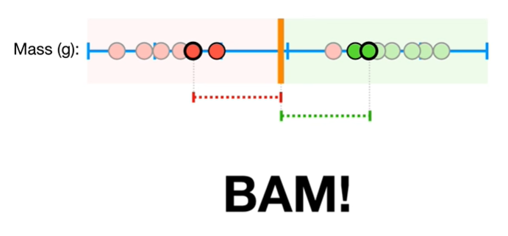

BAM !!!

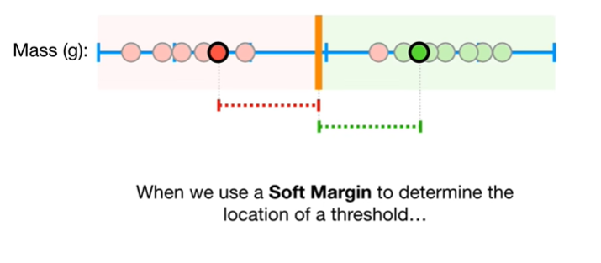

When we use a soft margin to determine the location of a threshold

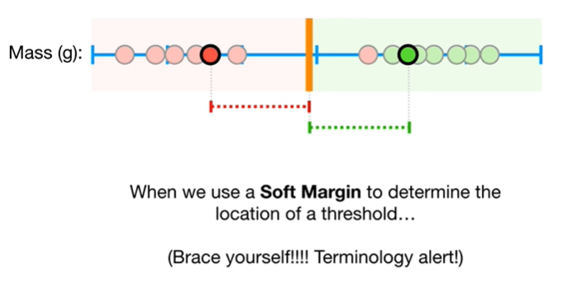

Brace yourself, we have another terminology alert !

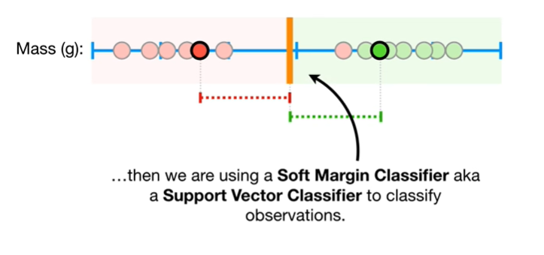

Then we are using a soft margin classifier aka a support vector classifier to classify observations.

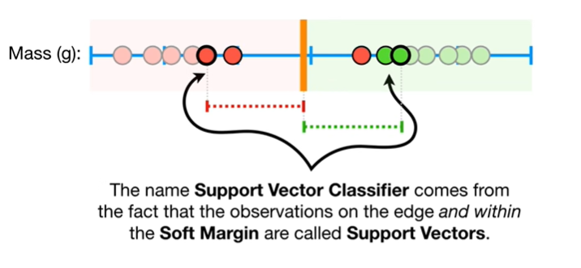

The names support vector classifier comes from the fact that the observations on the edge and within the soft margin are called support vectors.

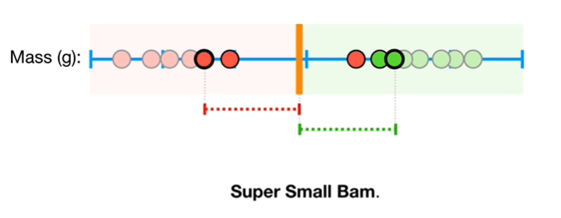

Super-small bam !

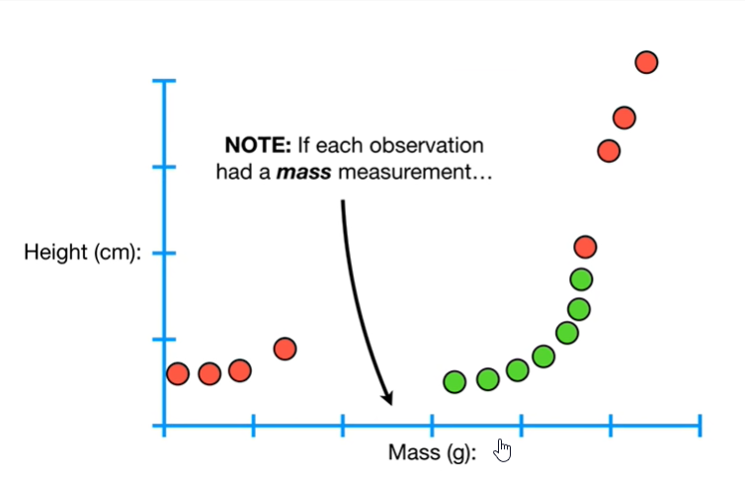

Note : if each observation had a mass measurement

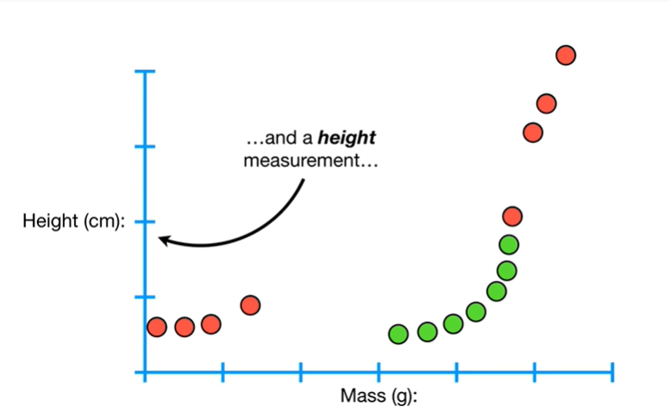

and a height measurement

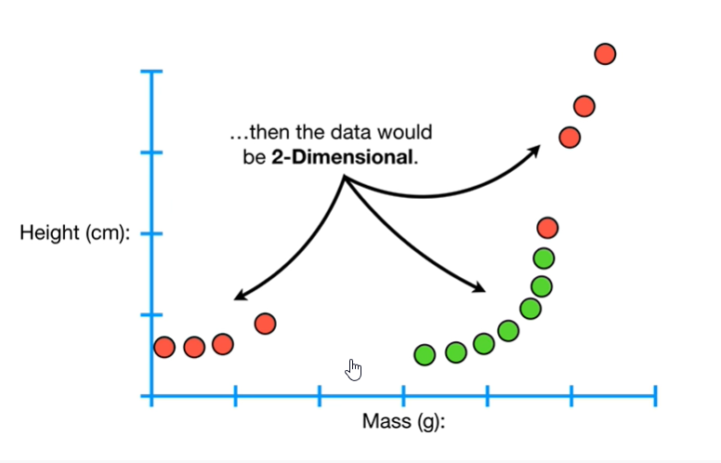

then the data would be two-dimensional.

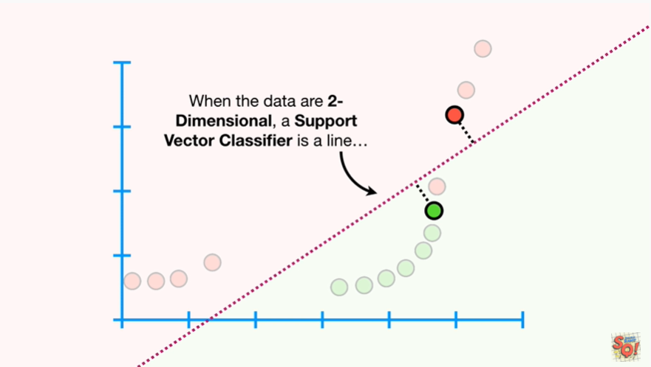

When the data are two-dimensional, a support vector classifier is a line

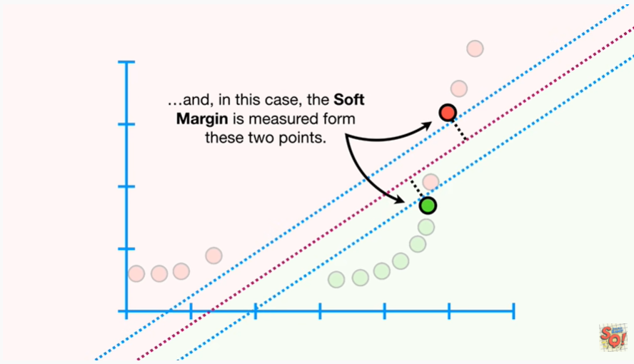

and in this case the soft margin is measured from these two points.

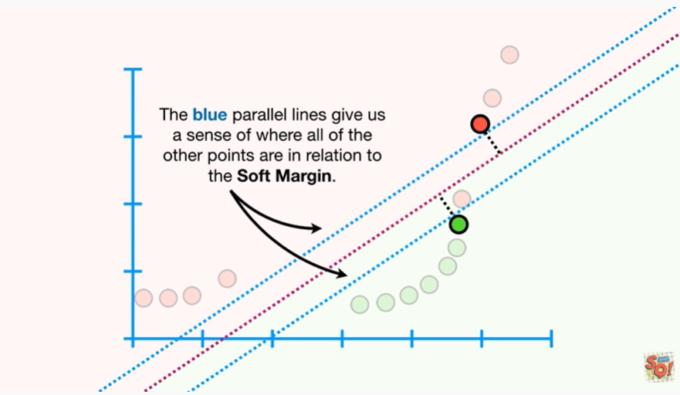

The blue parallel lines give us a sense of where all of the other points are in relation to the soft margin.

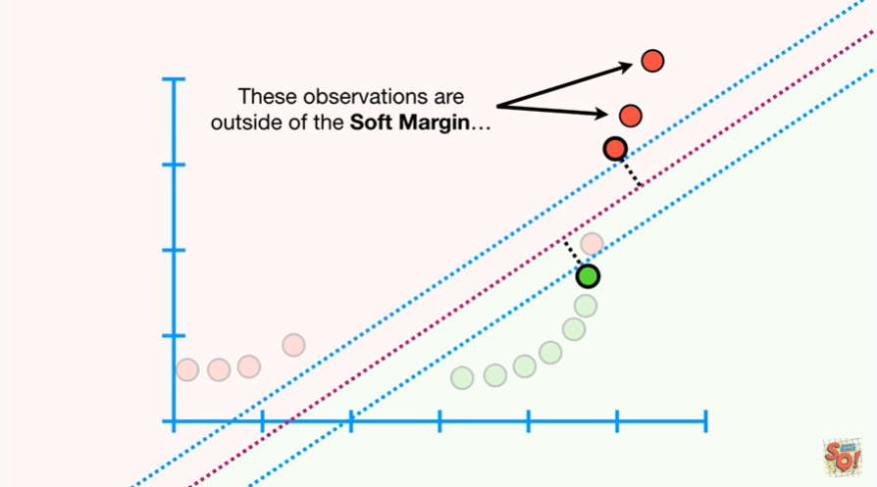

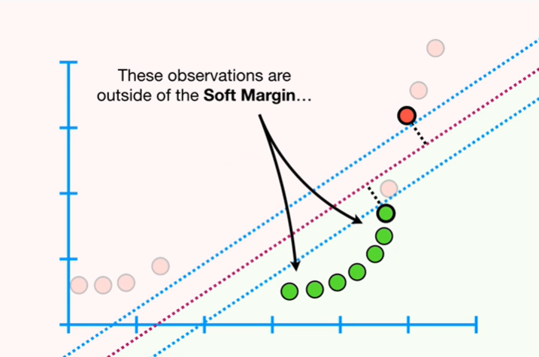

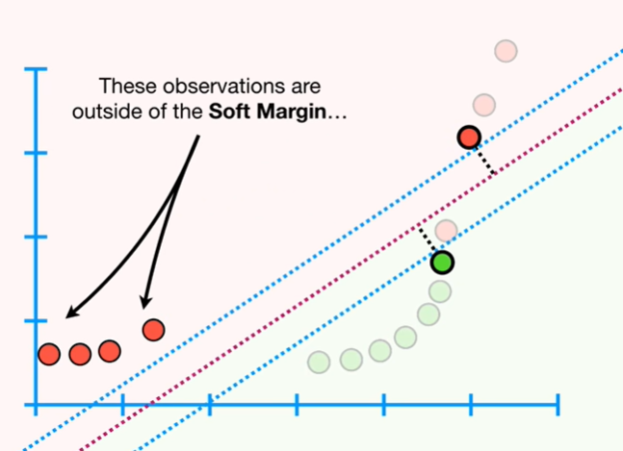

These observations are outside of the soft margin

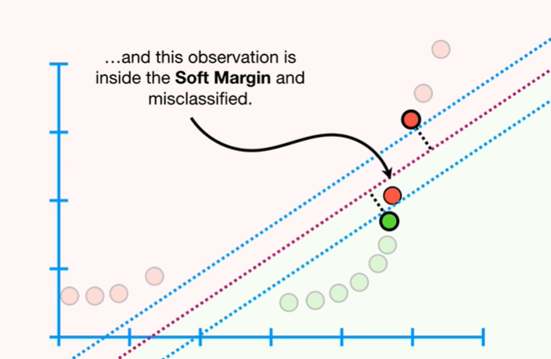

and this observation is inside the soft margin and misclassified.

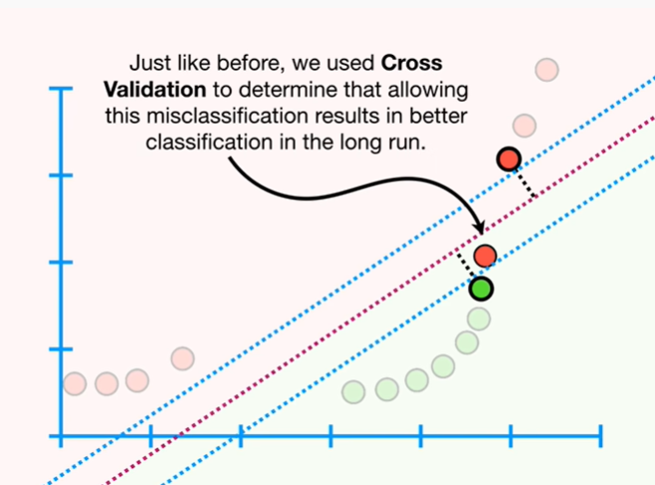

Just like before we used cross-validation to determine that allowing this miss classification results in better classification in the long run.

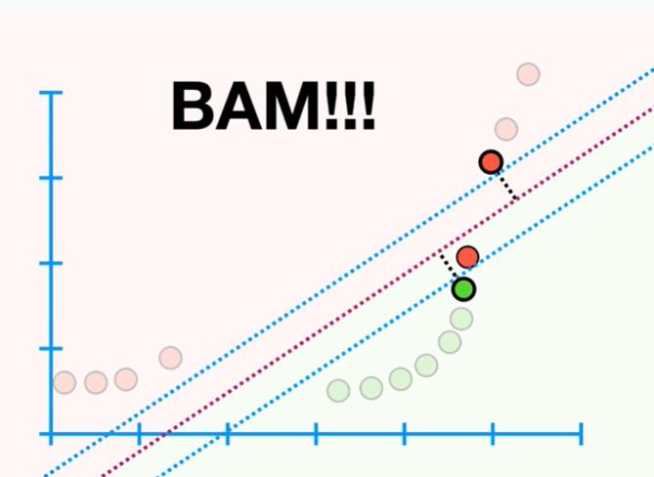

BAM !!!

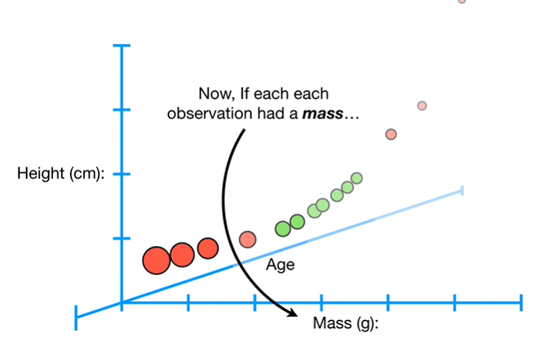

Now if each observation has a mass

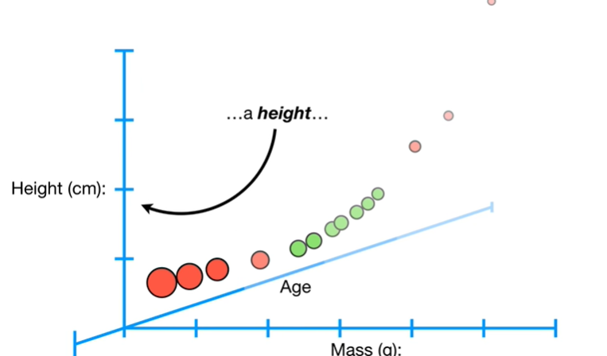a height

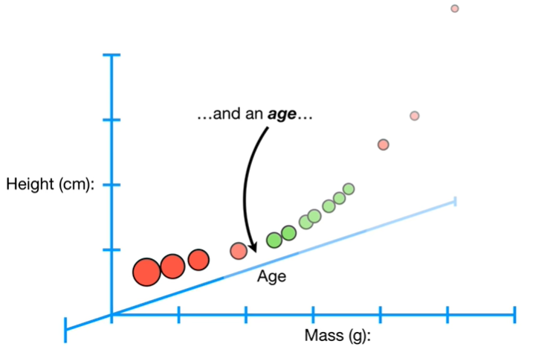

and an age

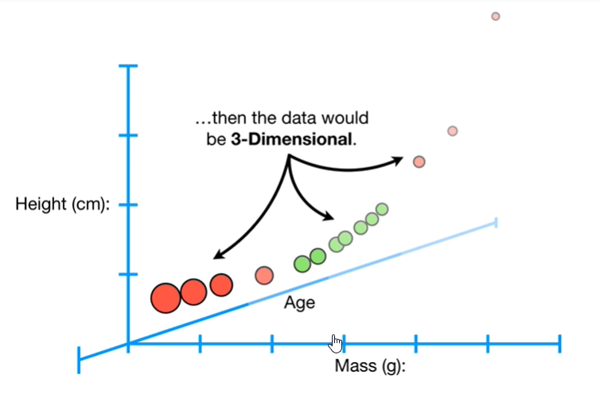

then the data would be three-dimensional.

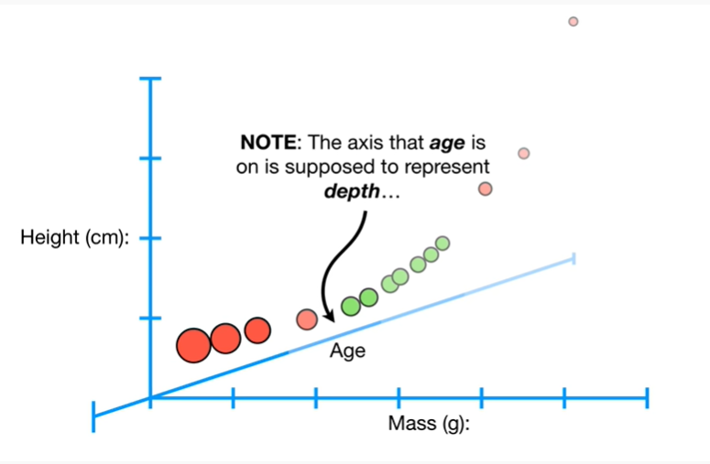

Note : the axis that age is on is supposed to represent depth

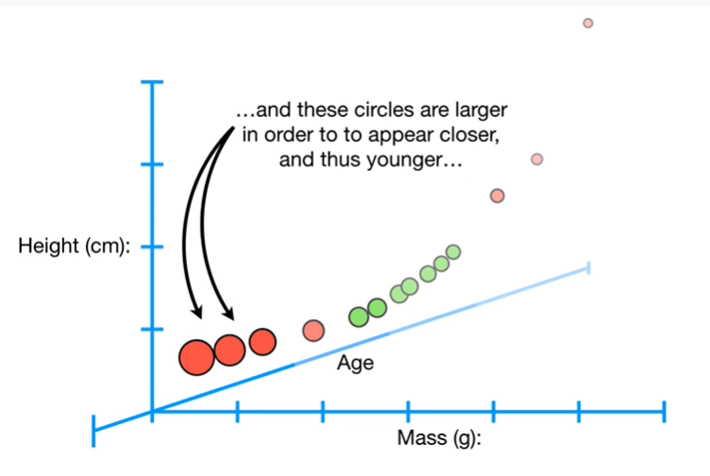

and these circles are larger in order to appear closer, and thus younger

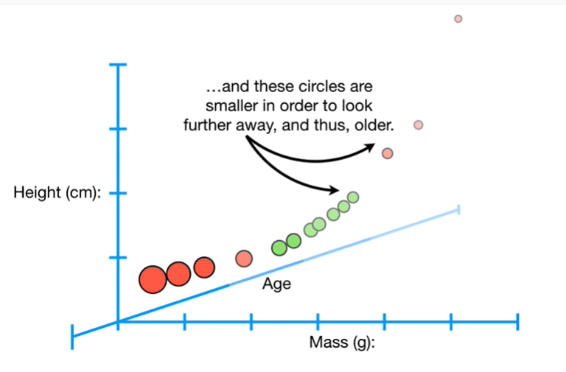

and these circles are smaller in order to look further away and thus older

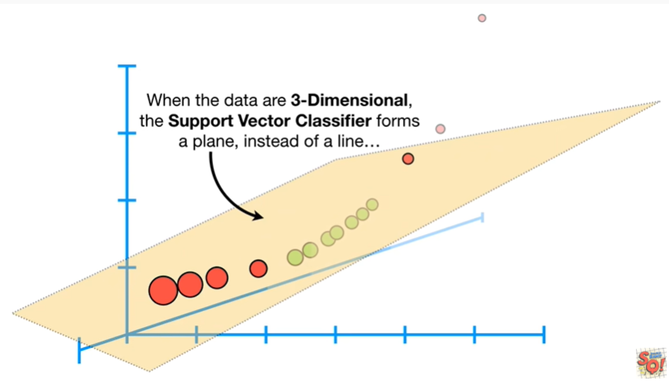

When the data are three-dimensional, the support vector classifier forms a plane, instead of a line

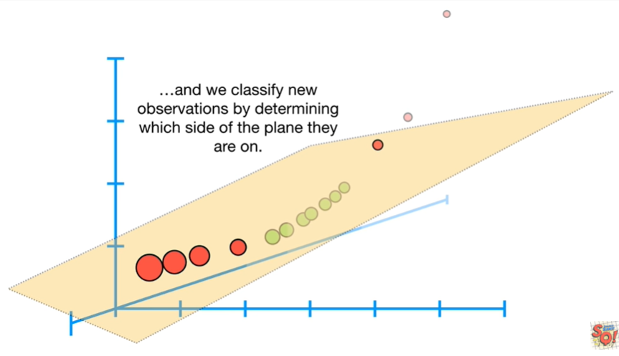

and we classify new observations by determining which side of the plane they are on.

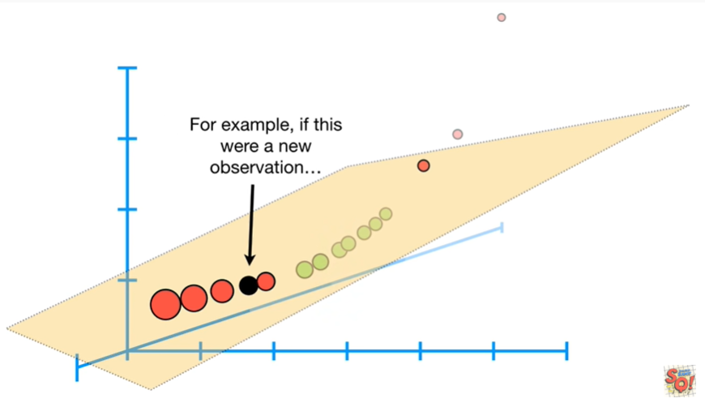

For example if this were a new observation

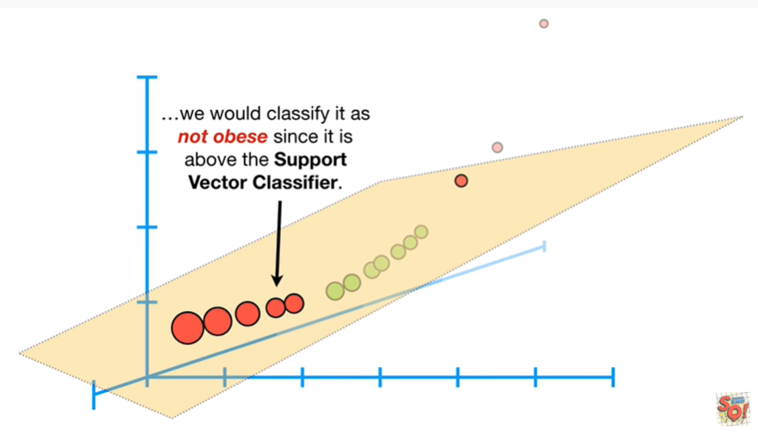

we would classify it as not obese since it is above the support vector classifier.

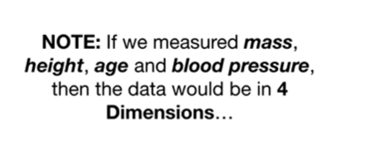

Note : if we measured mass, height, age and blood pressure, then the data would be in four dimensions

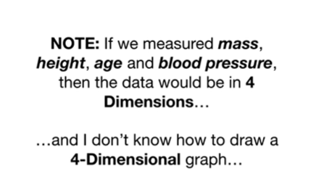

and I don't know how to draw four dimensional graph.

Wah-wah …

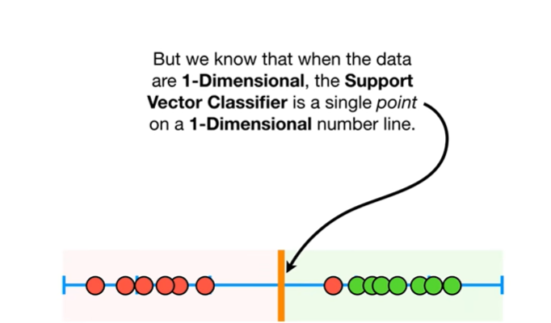

But we know that when the data are one-dimensional the support vector classifier is a single point on a one-dimensional number line.

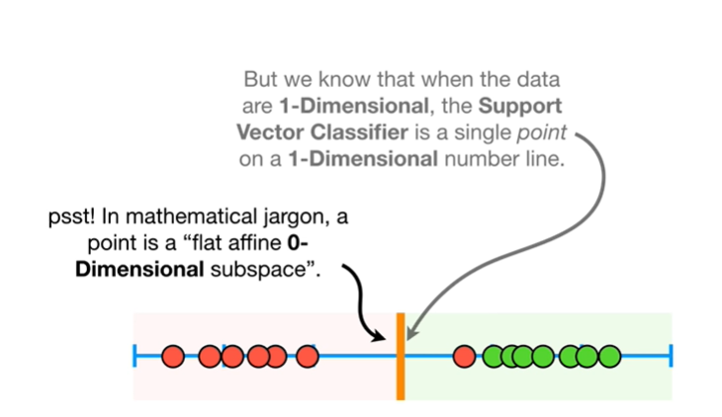

Psst : just in mathematical jargon a point is a flat affin zero dimensional subspace.

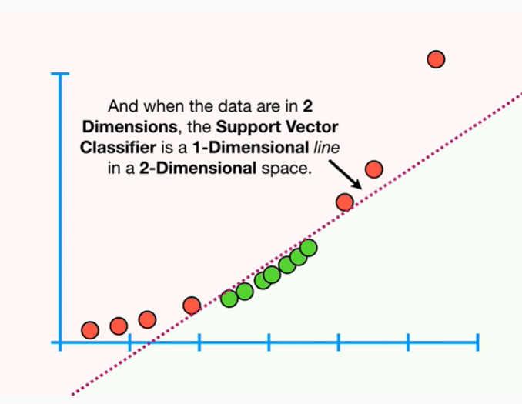

And when the data are in two dimensions, the support vector classifier is a one-dimensional line in a two dimensional space.

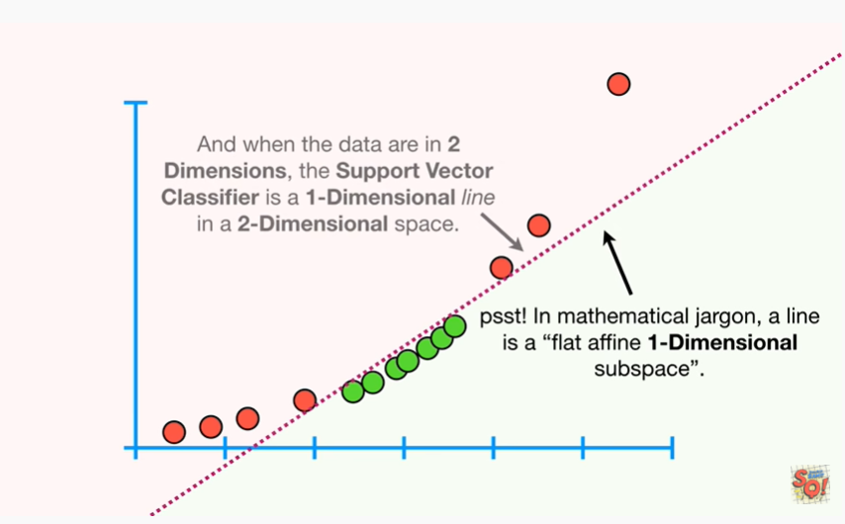

Psst : in mathematical jargon a line is a flat affin one-dimensional subspace.

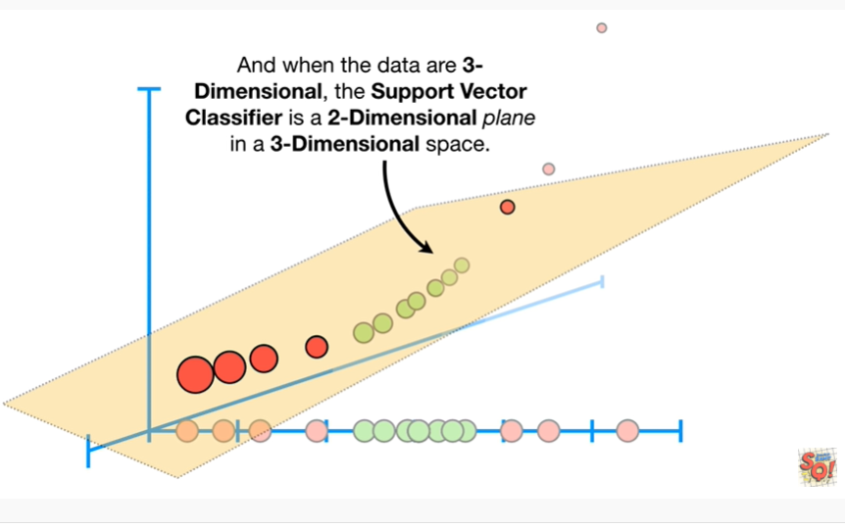

And when the data are three-dimensional the support vector classifier is a two-dimensional plane in a three-dimensional space.

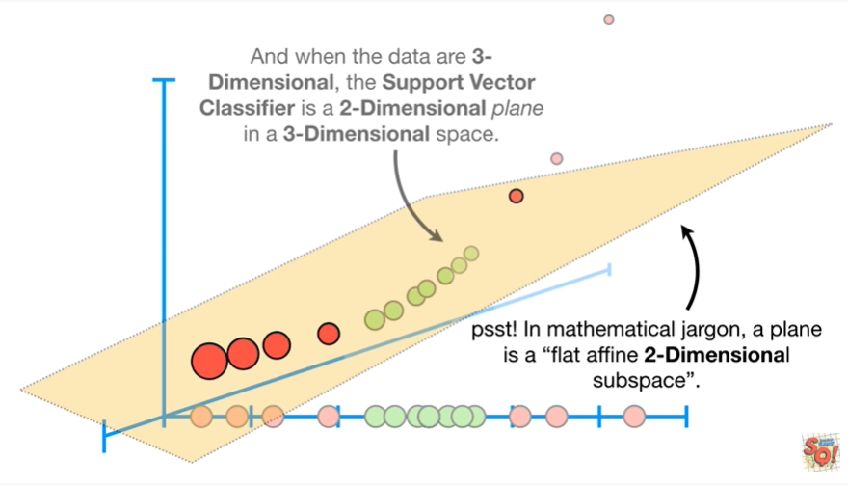

Psst : in mathematical jargon a plane is a flat affin two dimensional subspace.

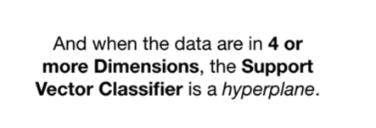

And when the data are in four or more dimensions, the support vector classifier is a hyperplane.

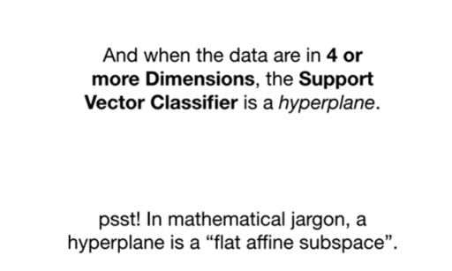

Psst : in mathematical jargon a hyperplane is a flat Athene subspace.

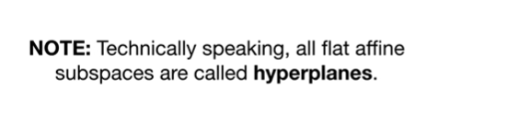

Note : technically speaking all flat affine subspaces are called hyperplanes.

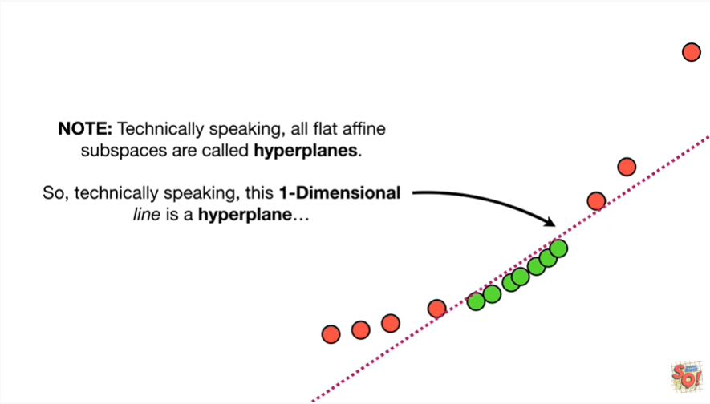

So technically speaking this one-dimensional line is a hyperplane

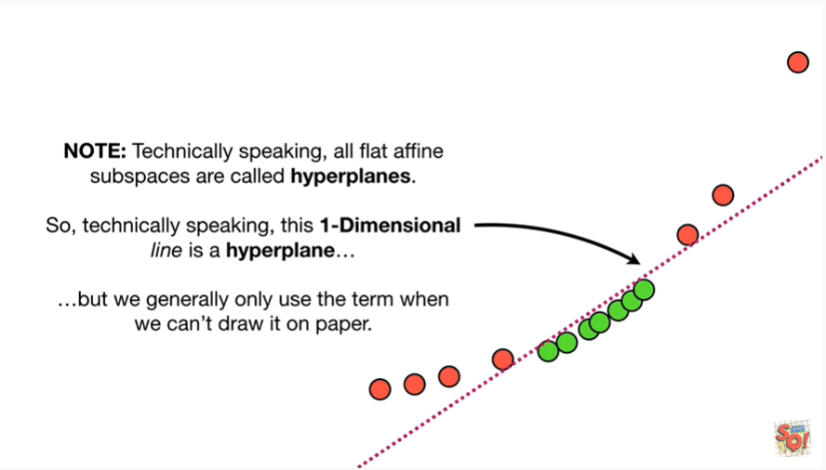

but we generally only use the term when we can't draw it on paper.

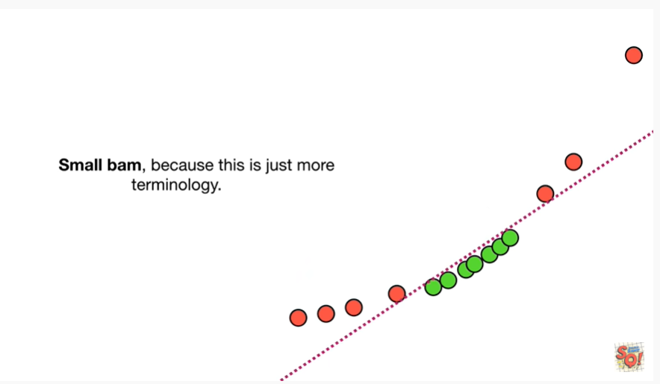

Small BAM, because this is just more terminology.

Ugh.

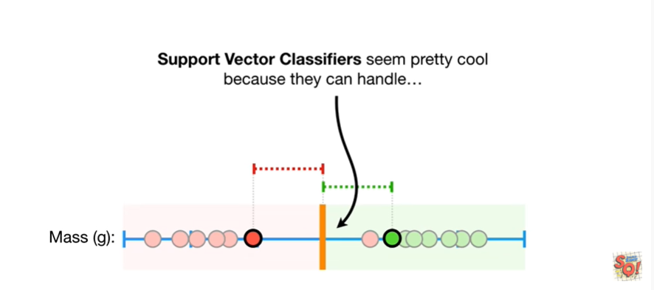

Support vector classifier seemed pretty cool because they can handle

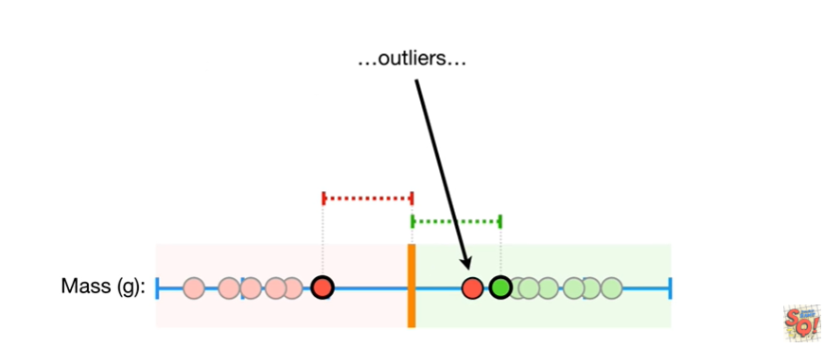outliers

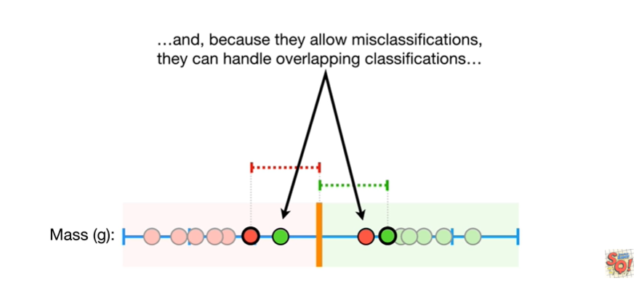

and because they can allow misclassifications they can handle overlapping classifications

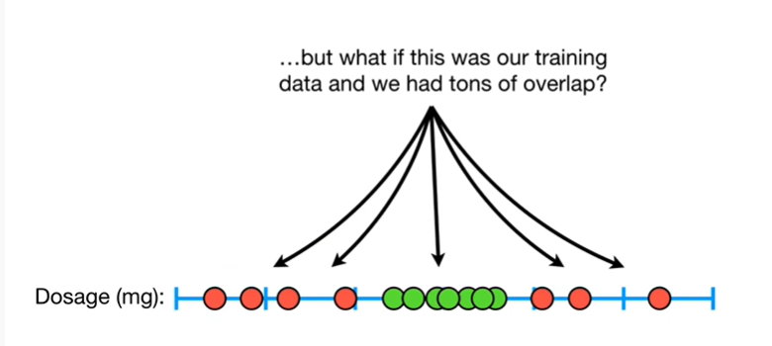

but what if this was our training data and we had tons of overlap ?

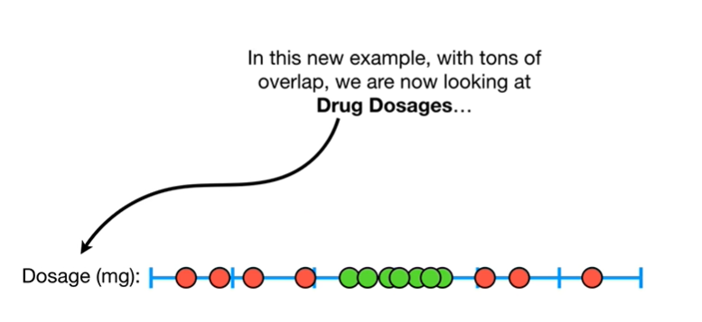

In this new example, with tons of overlap, we are now looking at drug dosages

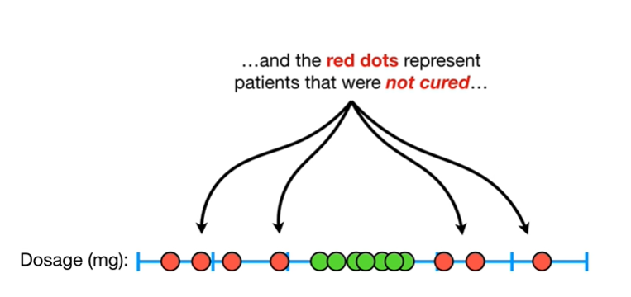

and the red dots represent patients that were not cured

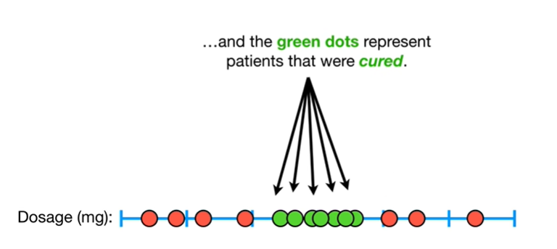

and the green dots represent patients that were cured.

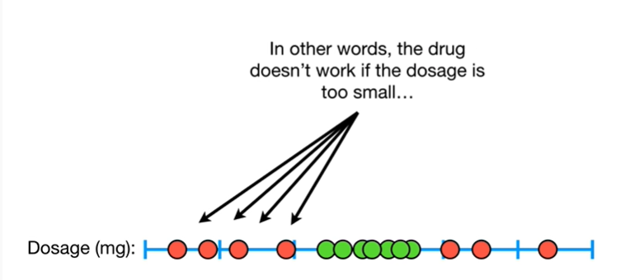

In other words, the drug doesn't work if the dosage is too small

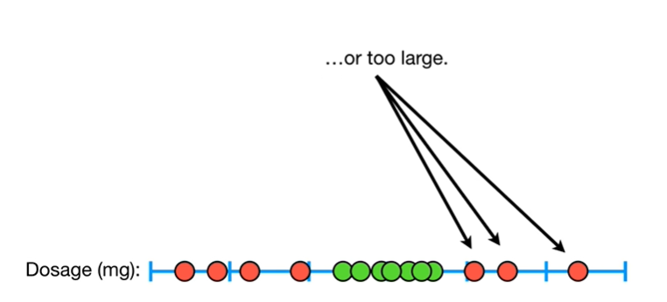

or too large.

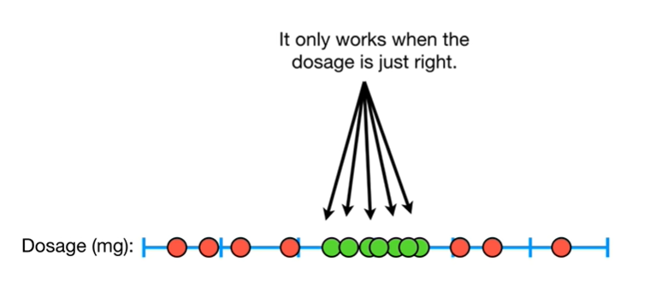

It only works when the dosage is just right.

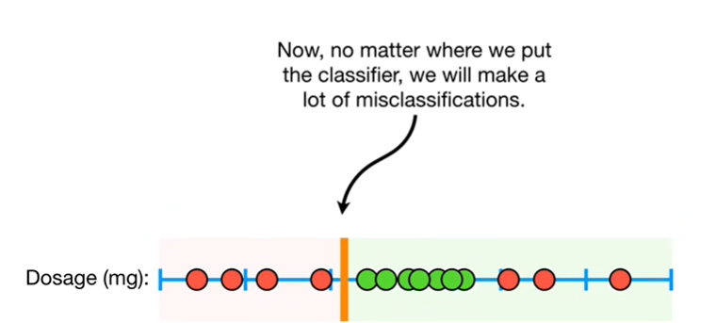

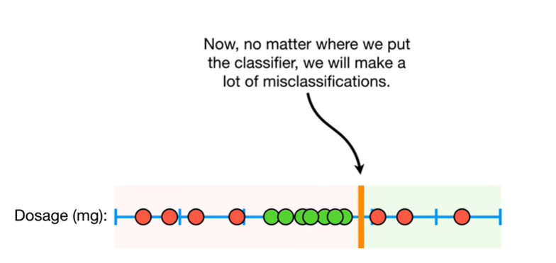

Now, no matter where we put the classifier, we will make a lot of misclassifications.

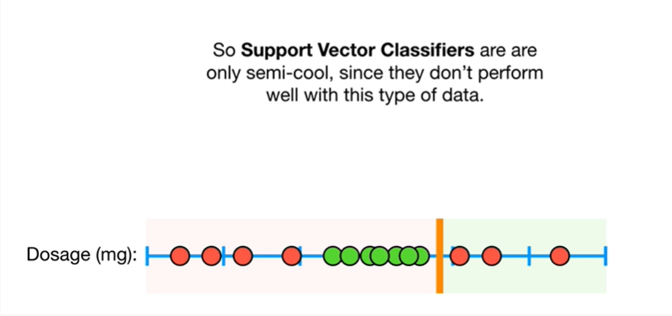

So support vector classifier are only semi-cool, since they don't perform well with this type of data.

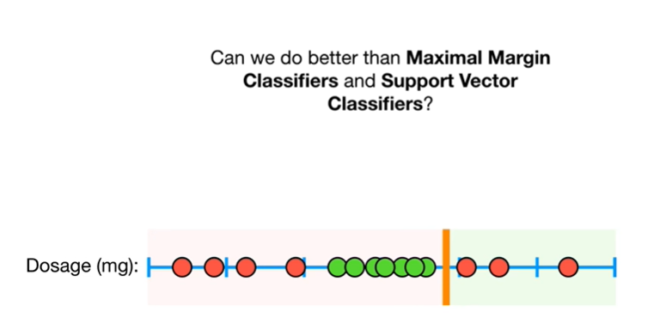

Can we do better than maximal margin classifiers and support vector classifier's ?

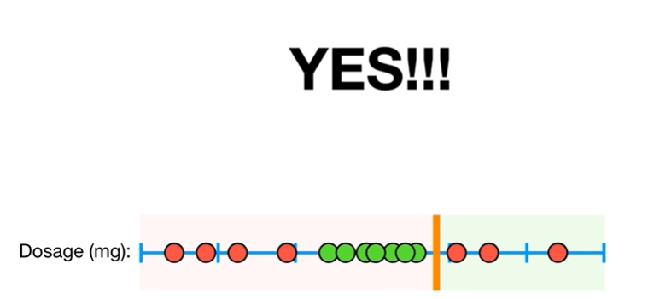

Yes !!!

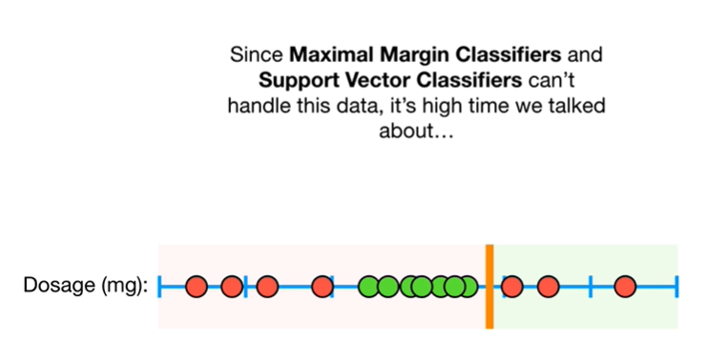

Since maximal margin classifiers and support vector classifier x' can't handle this data, it's high time we talked about

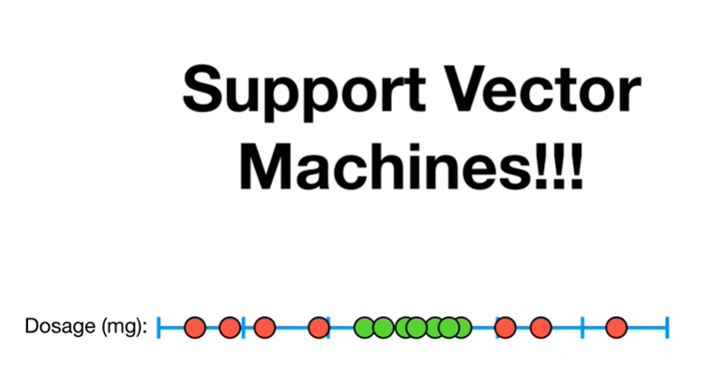

support vector machines.

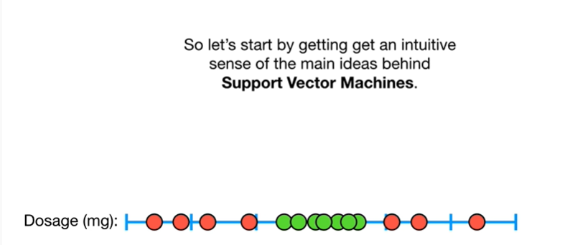

So let's start by getting an intuitive sense of the main ideas behind support vector machines.

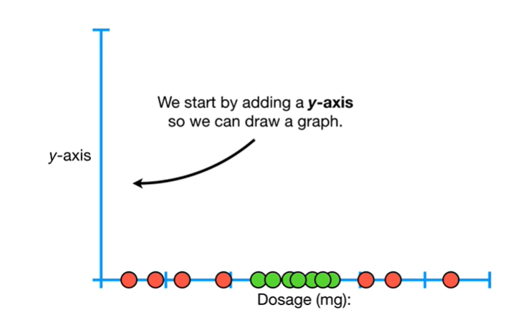

We start by adding a y-axis so we can draw a graph.

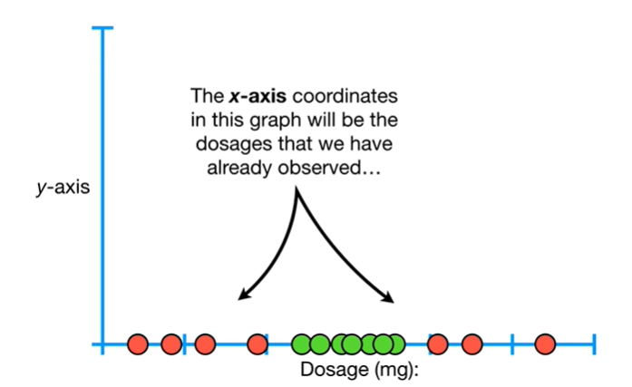

The x axis coordinates in this graph will be the dosages that we have already observed

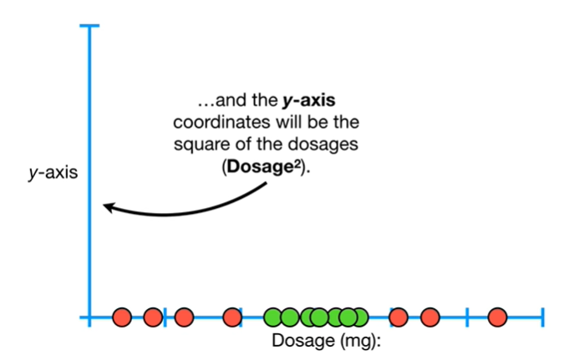

and the y axis coordinates will be the square of the dosages .

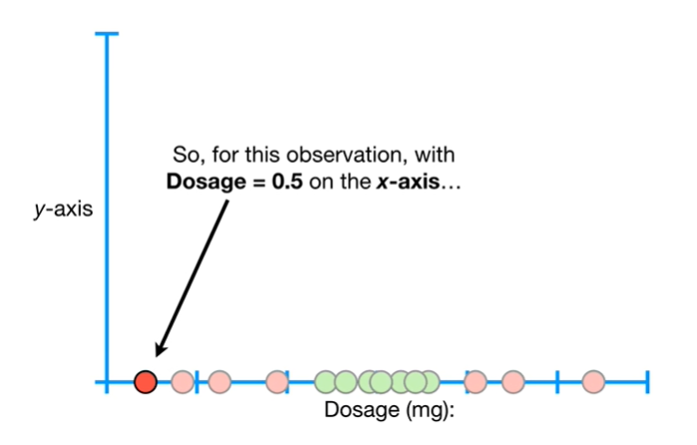

So for this observation with dosage equals 0.5 on the x axis

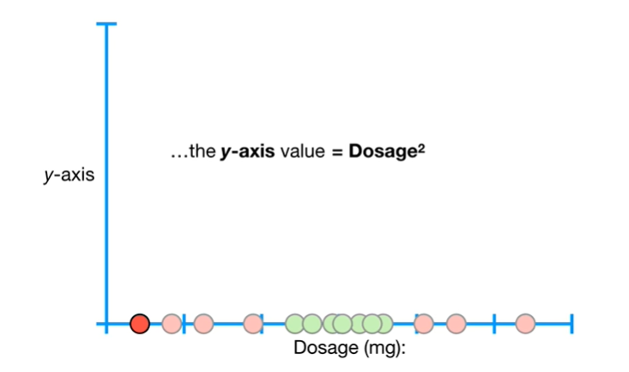

the y axis value equals dosage squared

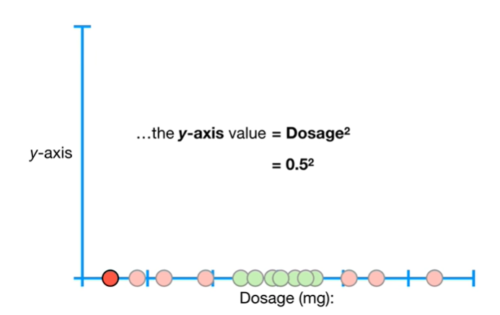

which equals 0.5 squared

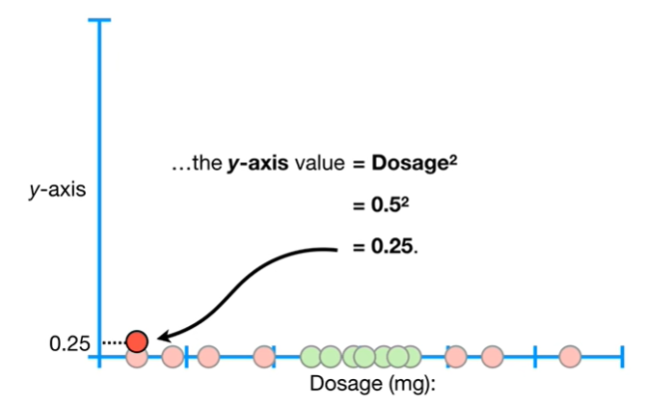

which equals 0.25.

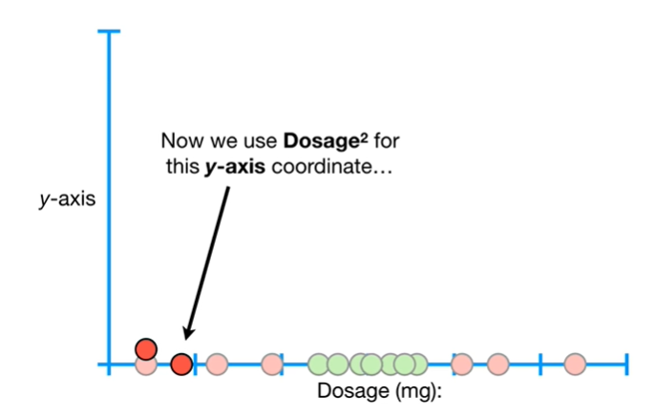

Now we use dosage squared for this y-axis coordinate

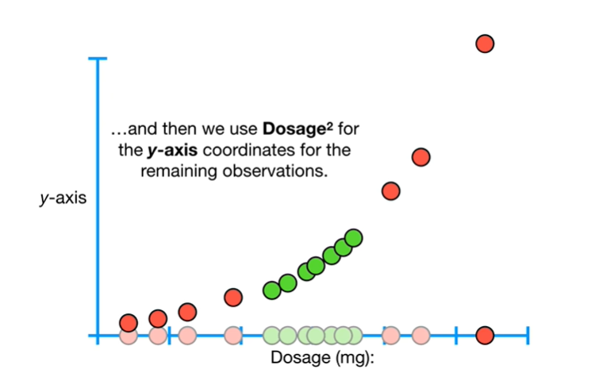

and then we use dosage squared for the y-axis coordinates for the remaining observations.

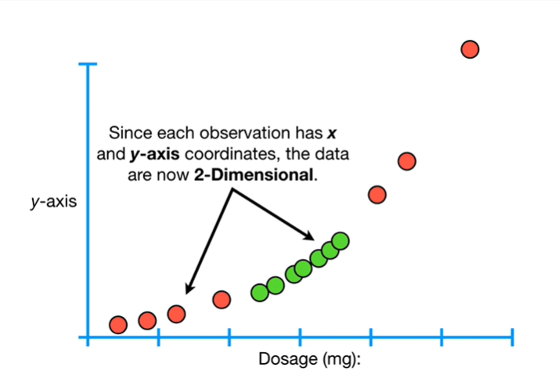

Since each observation has X and y-axis coordinates, the data are now two-dimensional.

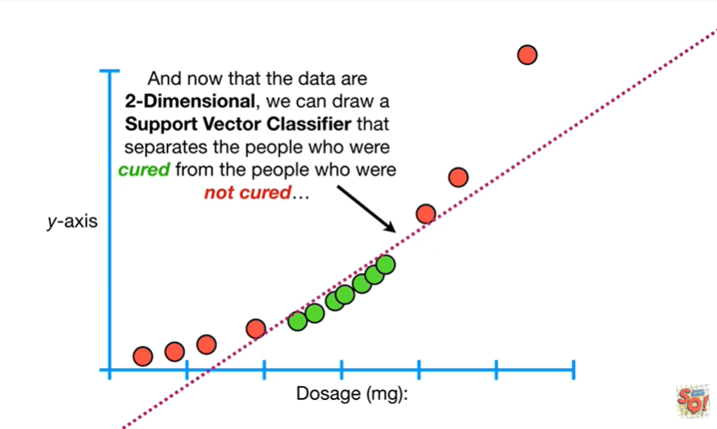

And now that the data are two-dimensional we can draw a support vector classifier that separates the people who were cured from the people who were not cured

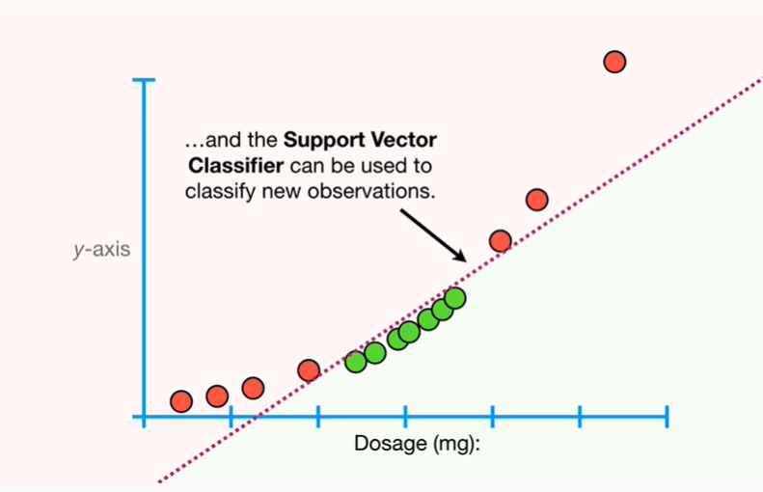

and the support vector classifier can be used to classify new observations.

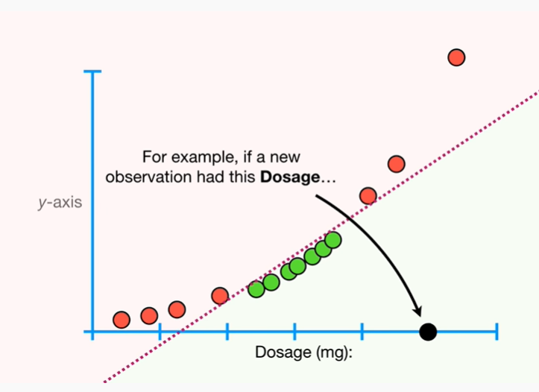

For example, if a new observation had this dosage

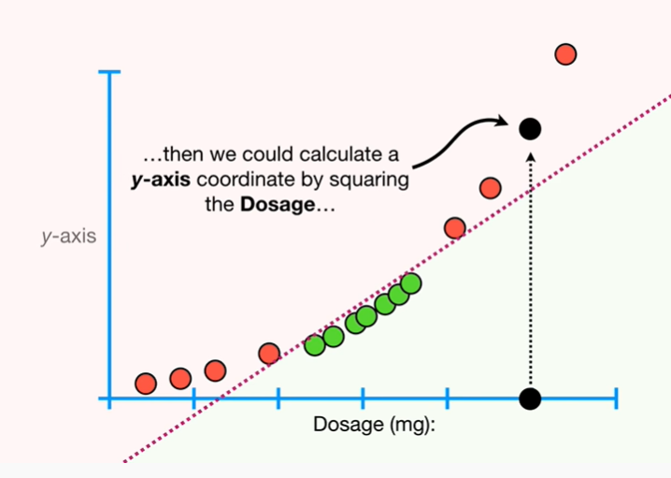

then we could calculate the y-axis coordinate by squaring the dosage

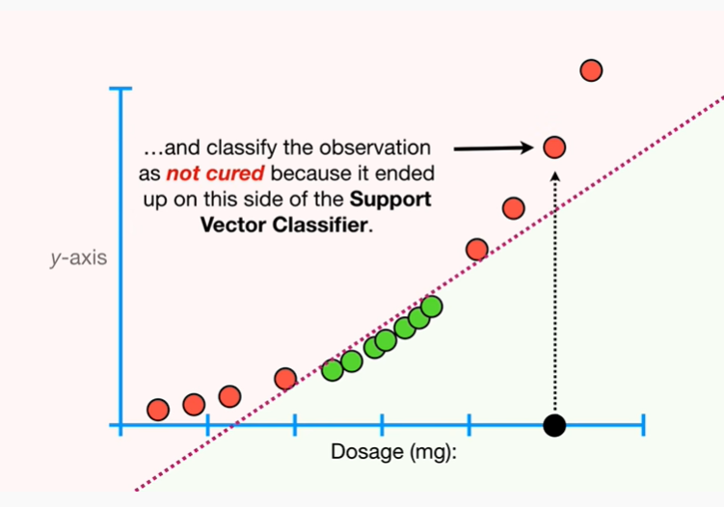

and classify the observation as not cured because it ended up on this side of the support vector classifier.

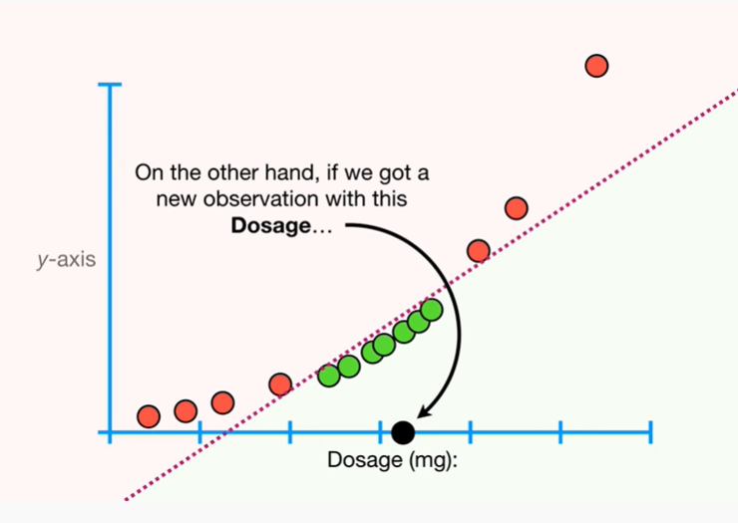

On the other hand if we got a new observation with this dosage

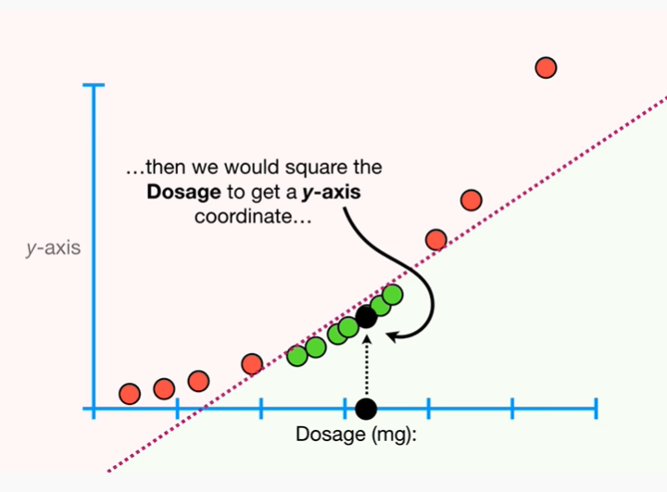

then we would square the dosage and get a y-axis coordinate

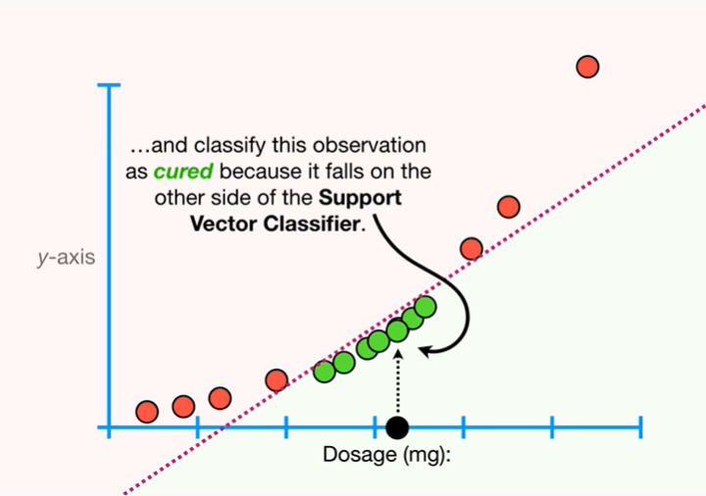

and classify this observation as cured because it falls on the other side of the support vector classifier.

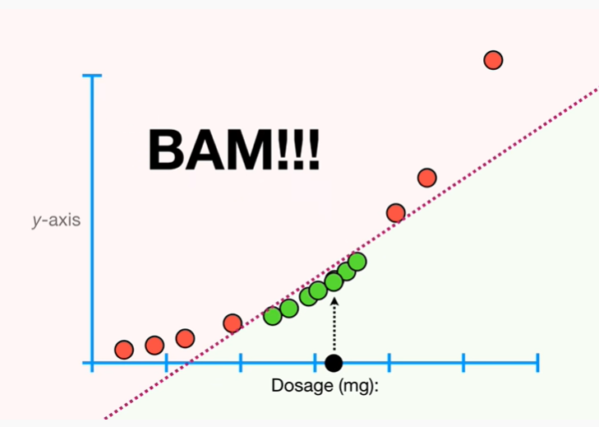

BAM !!!

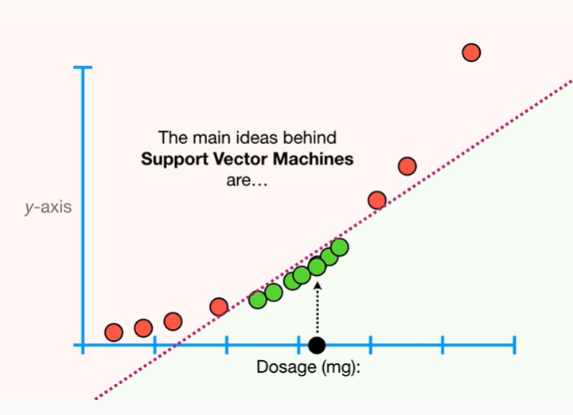

The main ideas behind support vector machines are :

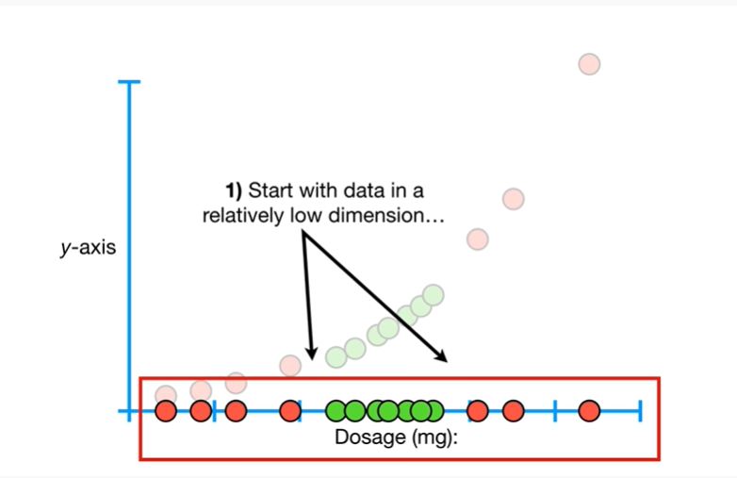

1. start with data in a relatively low dimension.

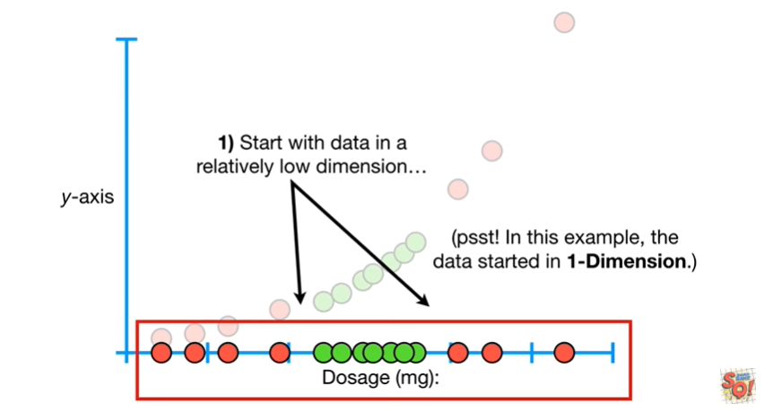

In this example the data started in one dimension.

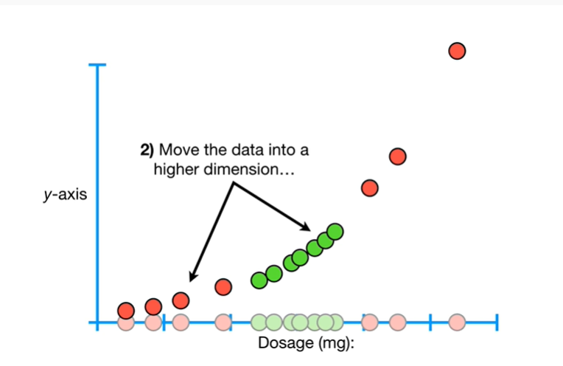

2. move the data into a higher dimension.

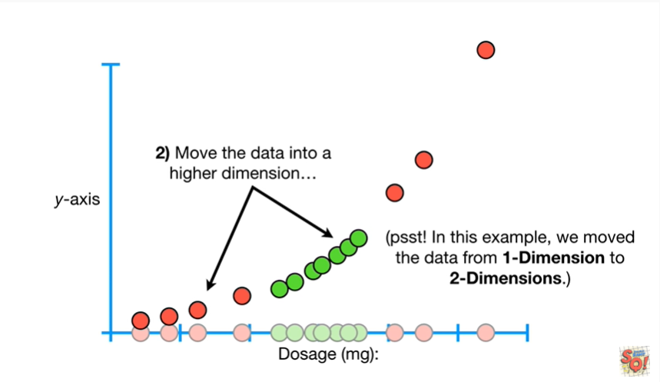

In this example we move the data from one dimension to two dimensions.

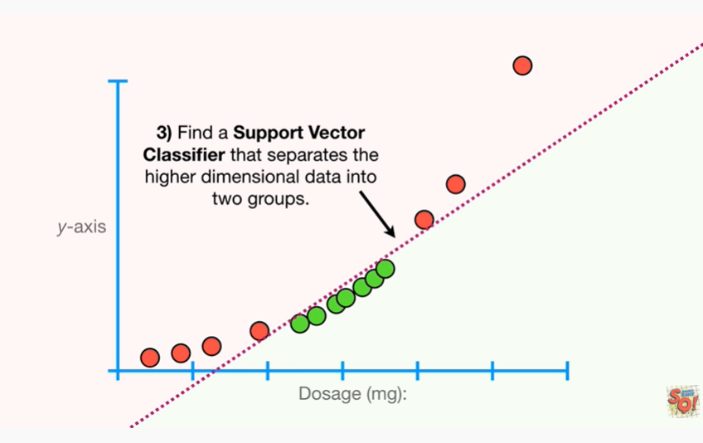

3. find a support vector classifier that separates the higher dimensional data into two groups.

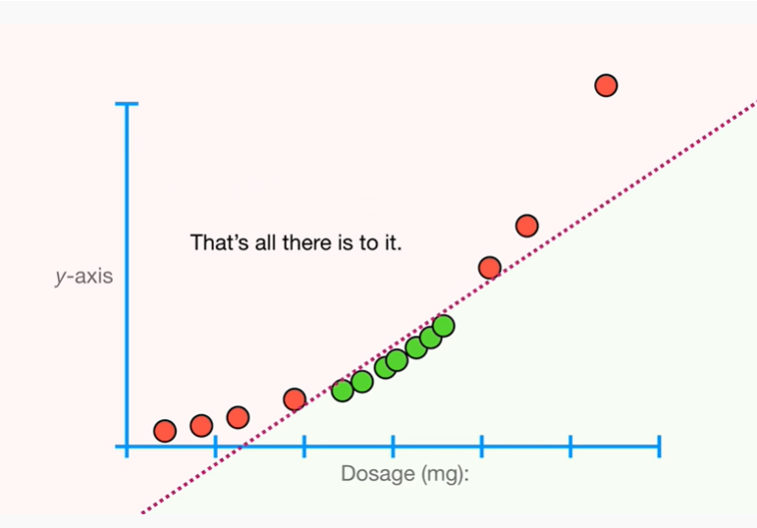

That's all there is to it.

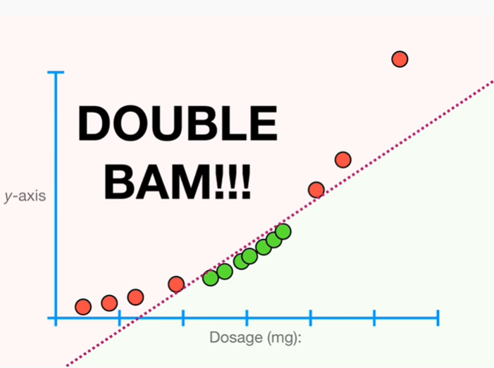

Double BAM !!!

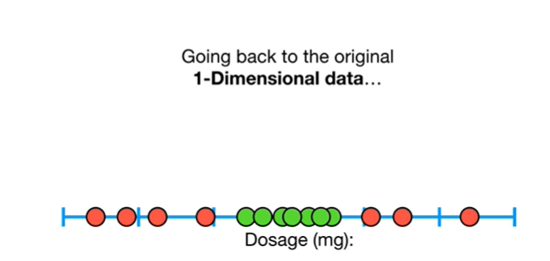

Going back to the original one dimensional data

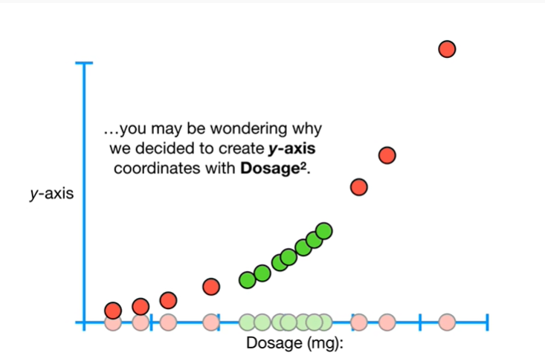

you may be wondering why we decided to create y-axis coordinates with dosage squared.

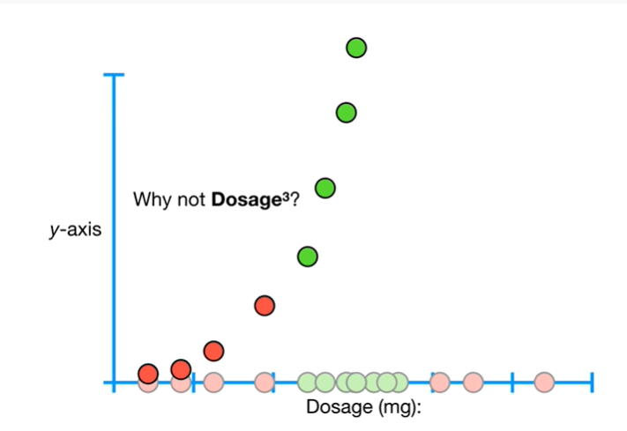

Why not dosage cubed ?

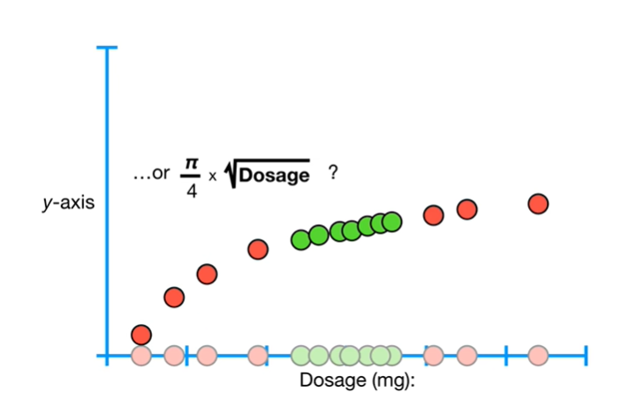

Or pi divided by four times the square root of dosage ?

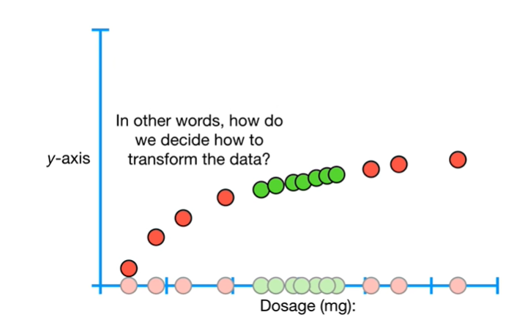

In other words how do we decide how to transform the data ?

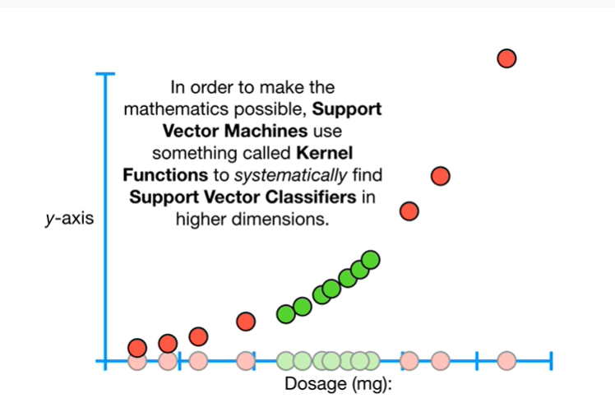

In order to make the mathematics possible, support vector machines use something called kernel functions to systematically find support vector classifier in higher dimensions.

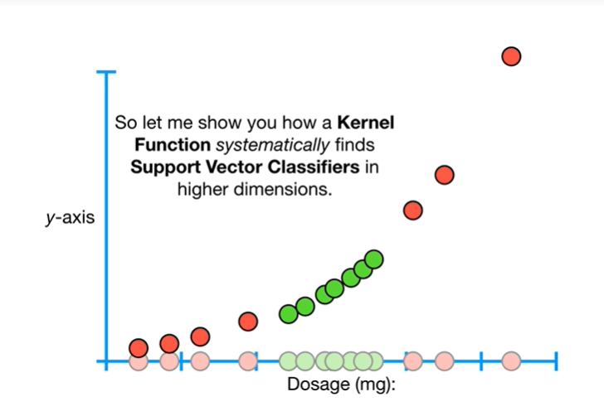

So let me show you how a kernel function systematically finds support vector classifier in higher dimensions.

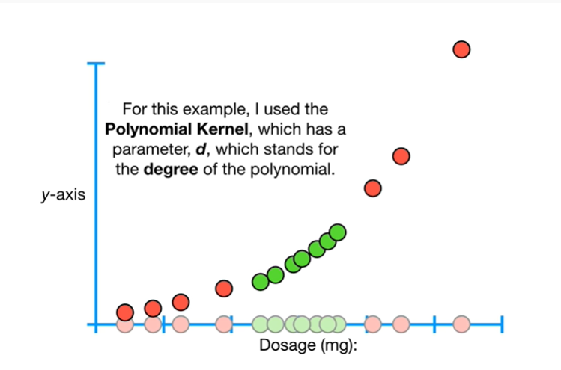

For this example, I use the polynomial kernel, which has a parameter, D, which stands for the degree of the polynomial.

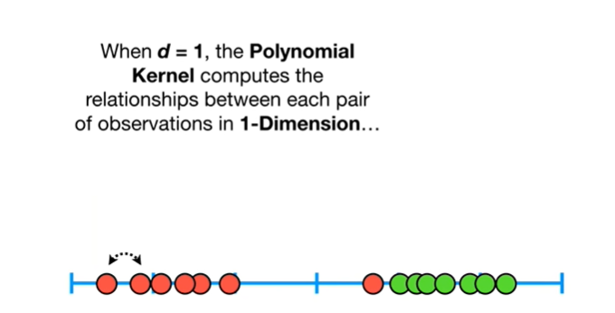

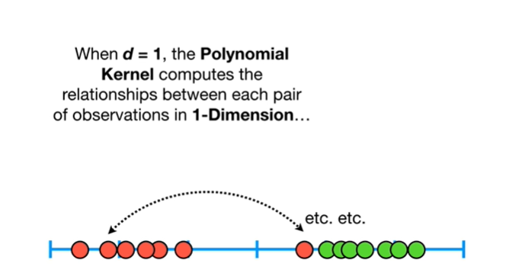

When D equals 1 the polynomial kernel computes the relationships between each pair of observations in one dimension

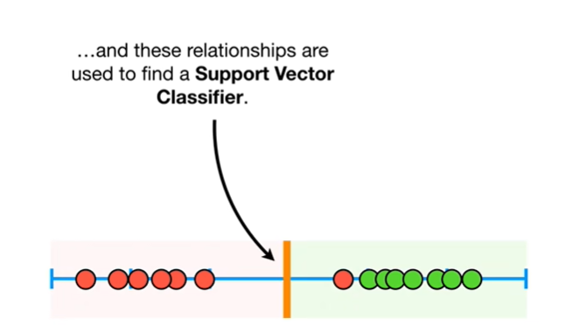

and these relationships are used to find a support vector classifier.

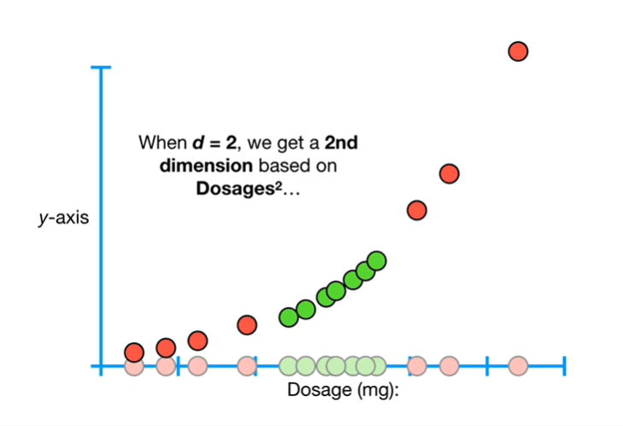

When D equals two, we get a second dimension based on dosages squared

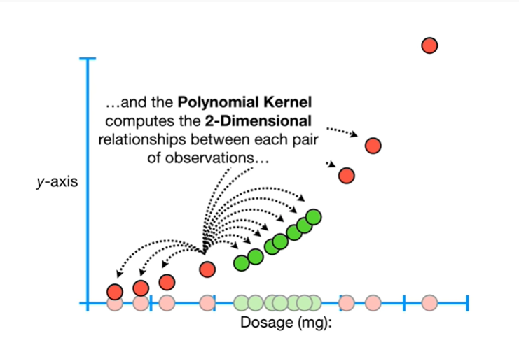

and the polynomial kernel computes the two-dimensional relationships between each pair of observations.

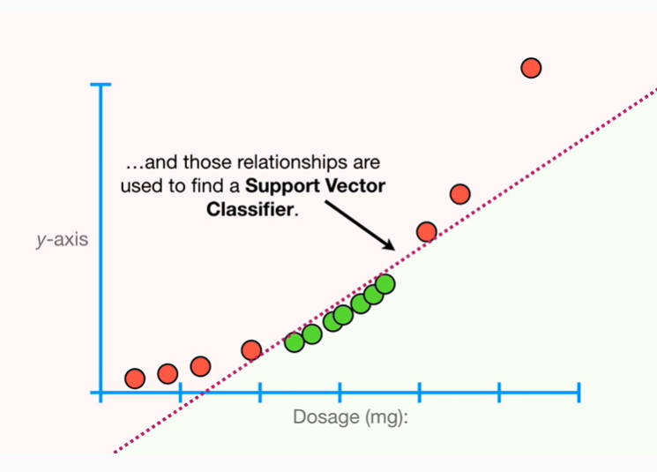

And those relationships are used to find a support vector classifier.

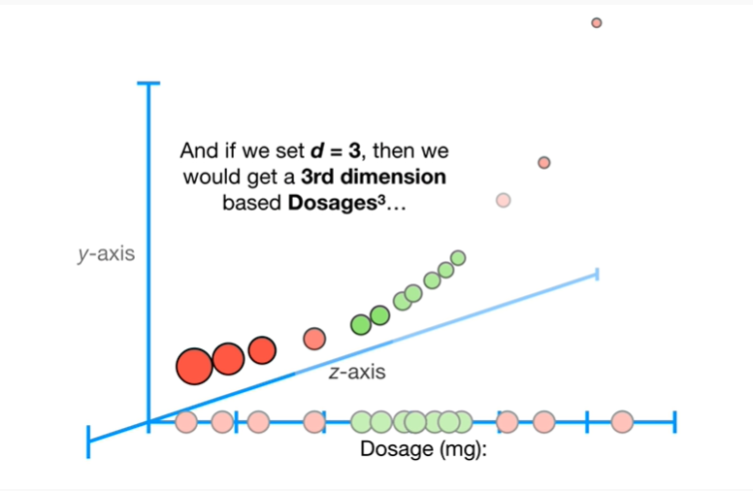

And when we set D equal three, then we would get a third dimension based on dosages cubed

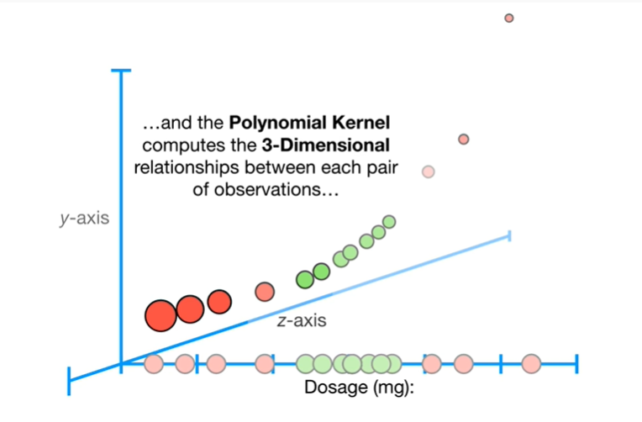

and the polynomial kernel computes the three-dimensional relationships between each pair of observations

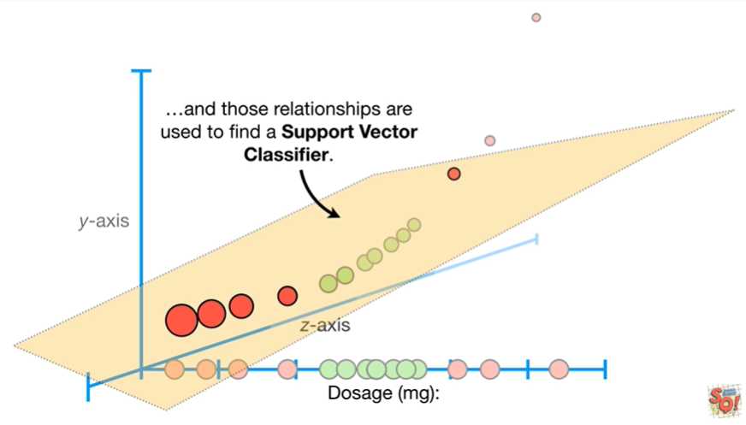

and those relationships are used to find a support vector classifier.

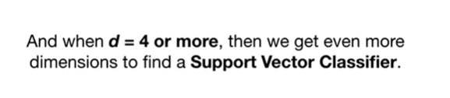

And when D equals four or more then we get even more dimensions to find a support vector classifier.

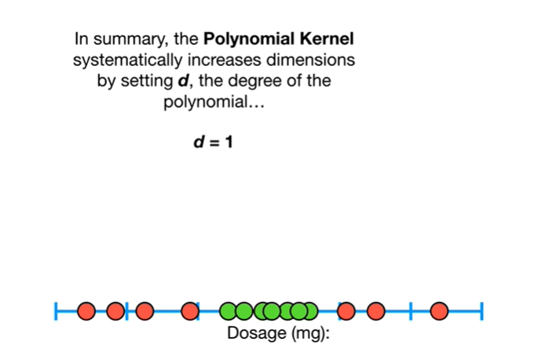

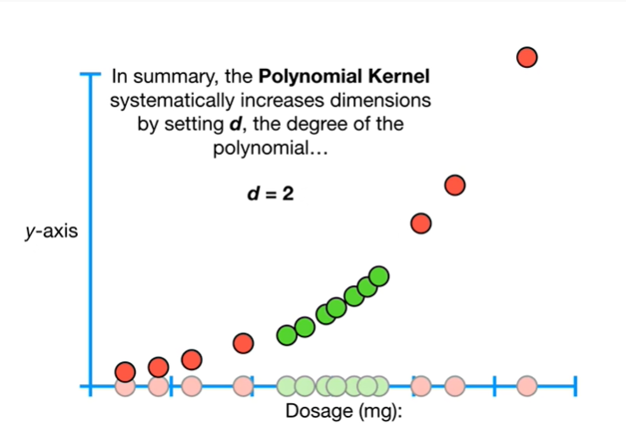

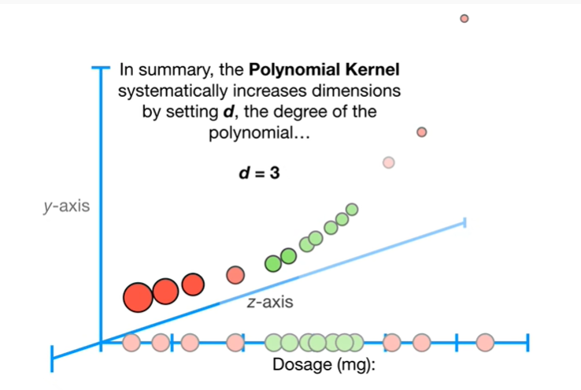

In summary, the polynomial kernel systematically increases dimensions by setting D, the degree of the polynomial

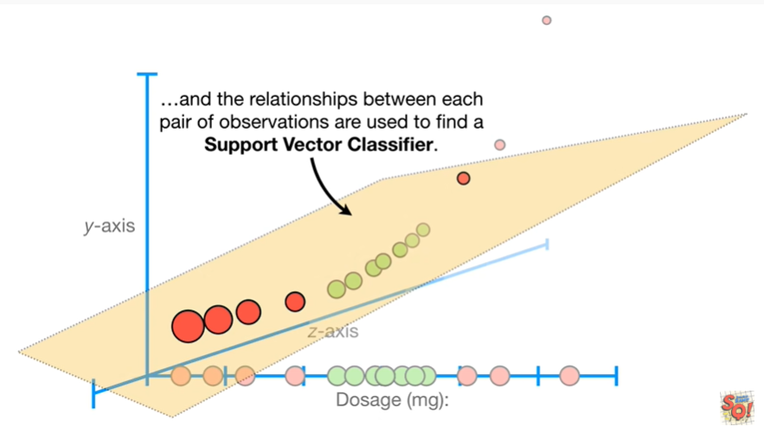

and the relationships between each pair of observations are used to find a support vector classifier.

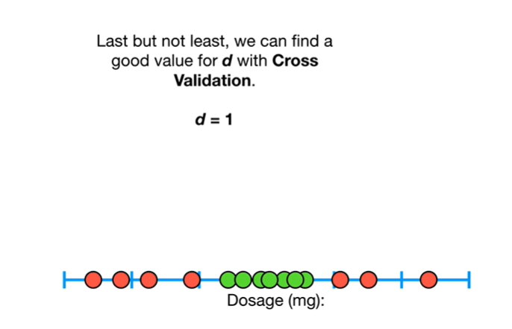

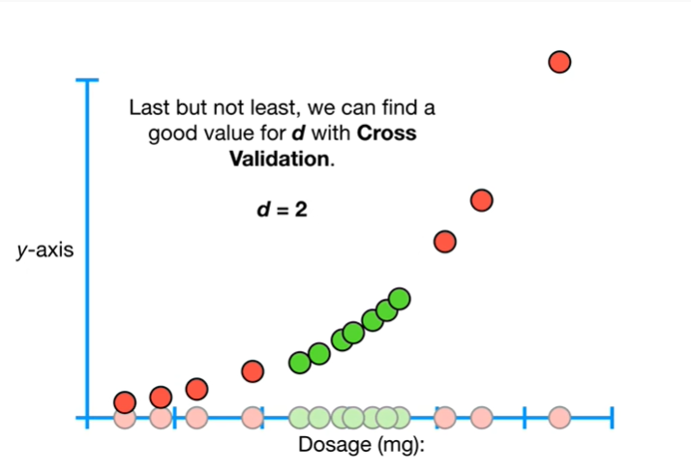

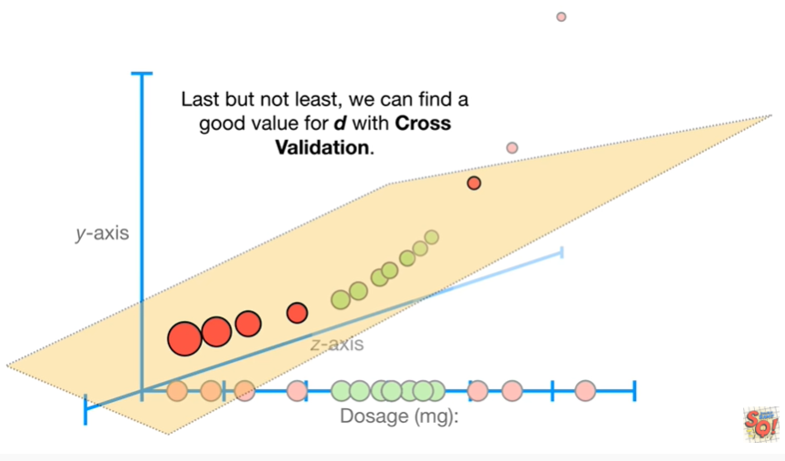

Last but not least, we can find a good value for D, with cross validation.

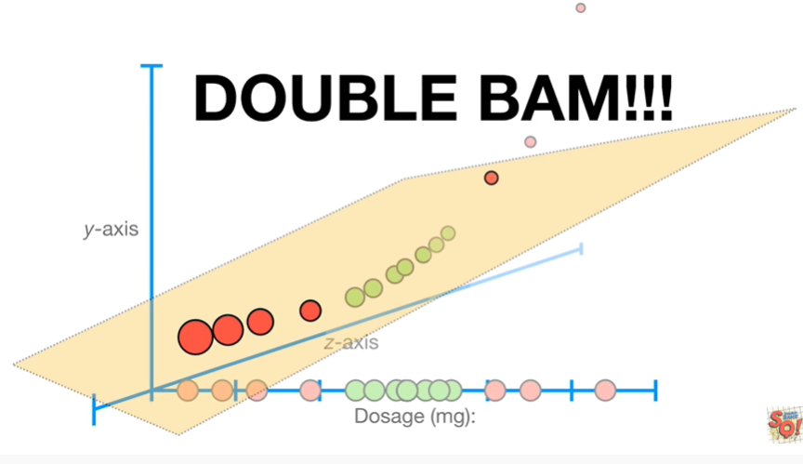

Double bam !!!

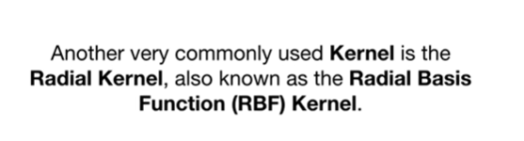

Another very commonly used kernel is the radial kernel also known as the radial basis function kernel.

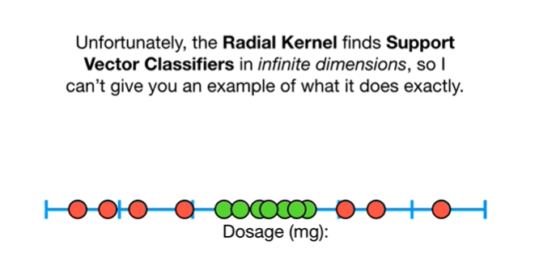

Unfortunately, the radio Colonel finds support vector classifier x' in infinite dimensions, so I can't give you an example of what it does exactly.

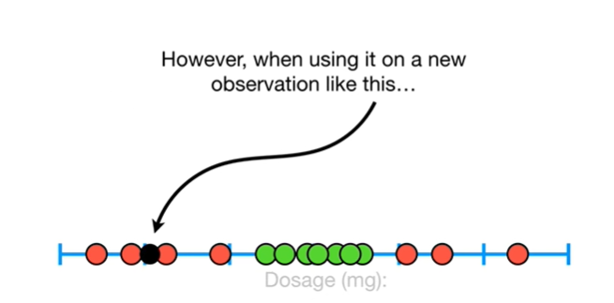

However, when using it on a new observation like this

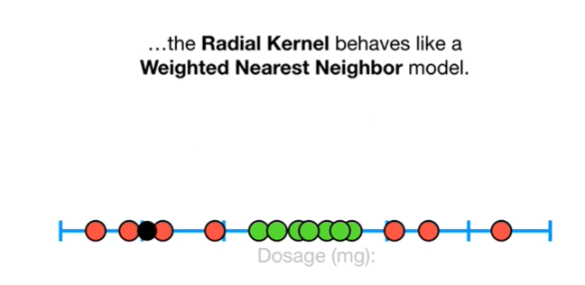

the radio kernel behaves like a weighted nearest neighbor model.

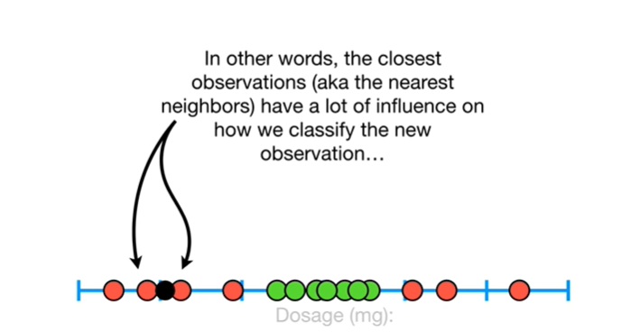

In other words, the closest observations aka the nearest neighbors have a lot of influence on how we classify the new observation

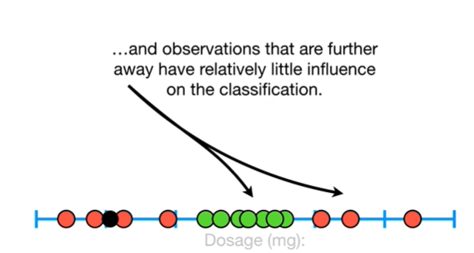

and observations that are further away have relatively little influence on the classification.

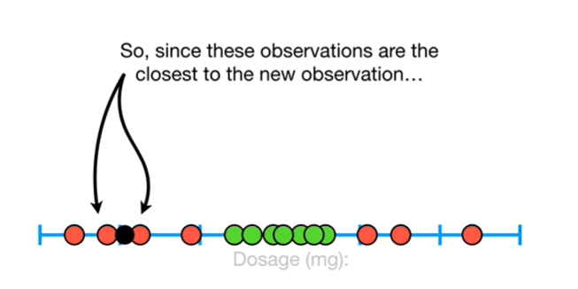

So, since these observations are the closest to the new observation

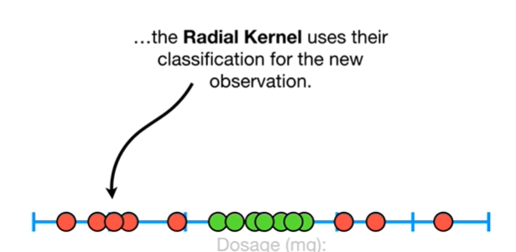

the radio kernel uses their classification for the new observation.

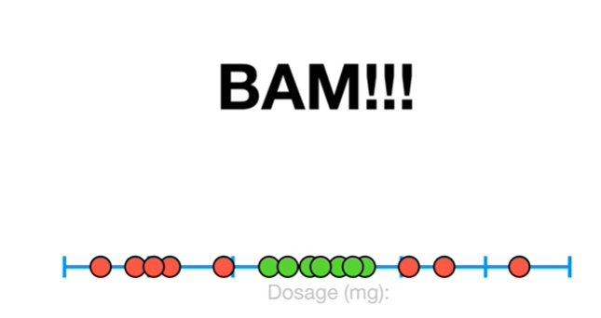

BAM !!!

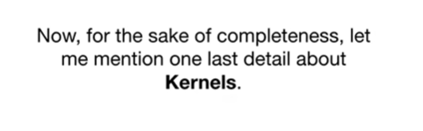

Now for the sake of completeness, let me mention one last detail about kernels.

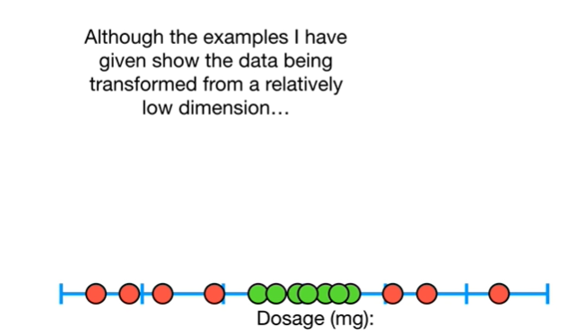

Although the examples I've given show the data being transformed from a relatively low dimension

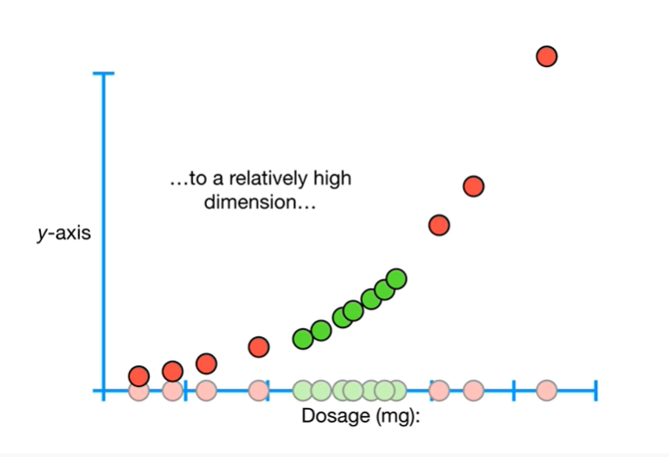

to a relatively high dimension

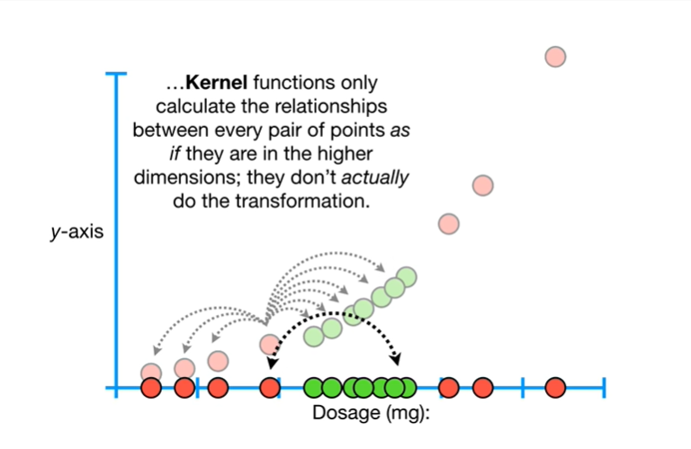

kernel functions only calculate the relationships between every pair of points as if they are in the higher dimensions ; they don't actually do the transformation.

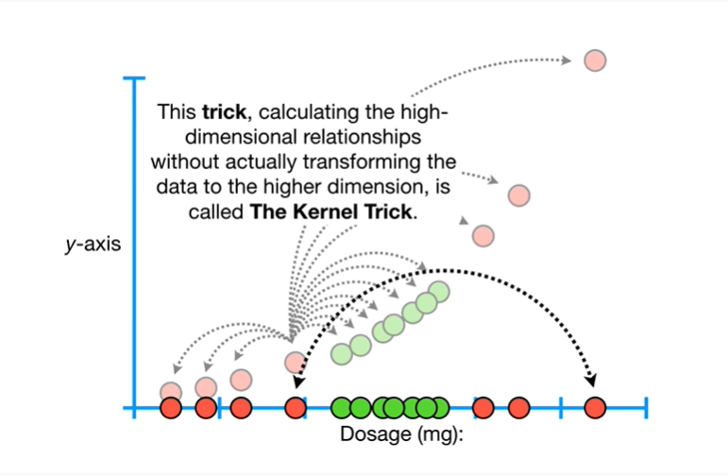

This trick, calculating the high-dimensional relationships without actually transforming the data to the higher dimension, is called the kernel trick.

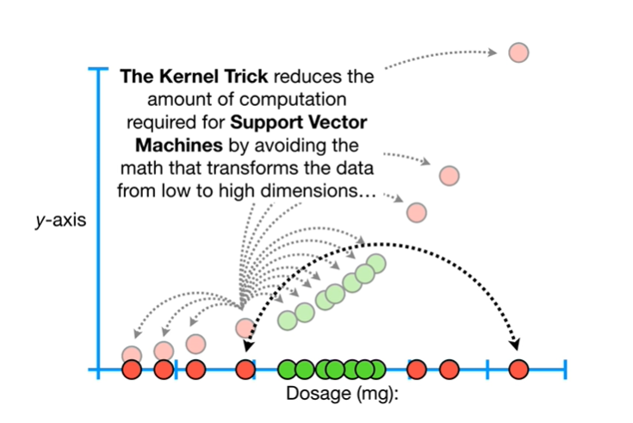

The kernel trick reduces the amount of computation required for support vector machines by avoiding the math that transforms the data from low to high dimensions

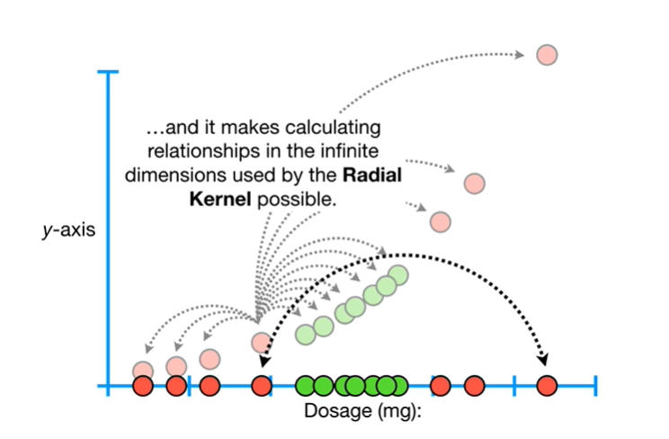

and it makes calculating the relationships in the infinite dimensions used by the radial kernel possible.

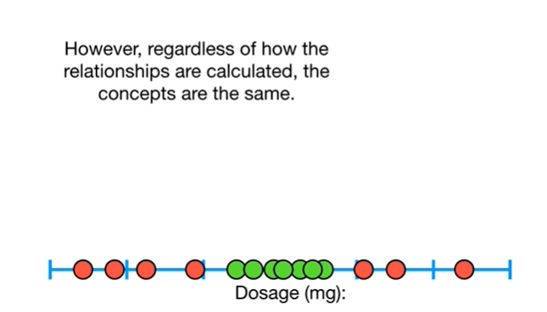

However regardless of how the relationships are calculated the concepts are the same.

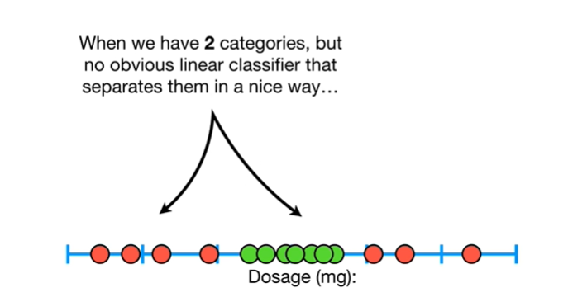

When we have two categories but no obvious linear classifier that separates them in a nice way

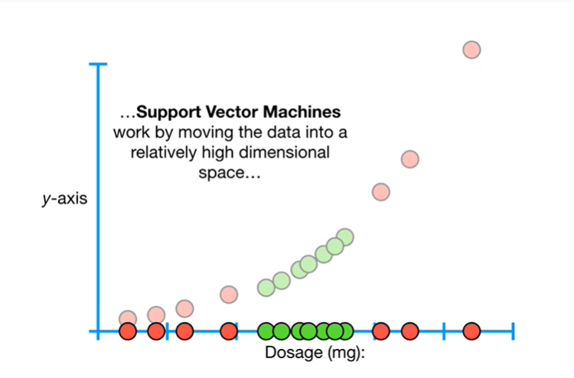

support vector machines work by moving the data into a relatively high dimensional space

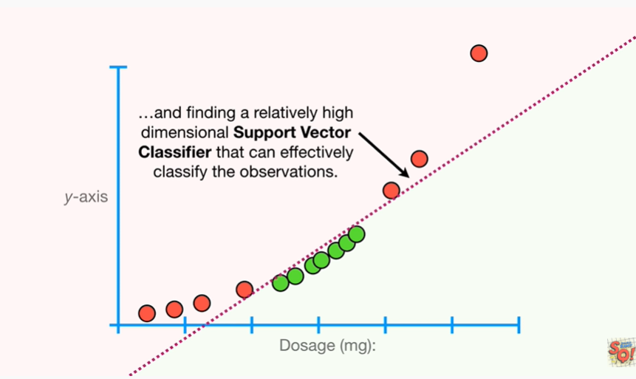

and finding a relatively high dimensional support vector classifier that can effectively classify the observations.

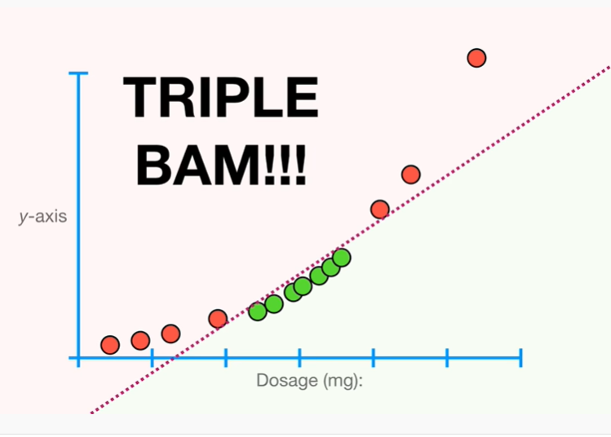

Triple bam !!!